 | Office of Research Innovation & Commercialization (ORIC)  Centre of Undergraduate Studies  University of the Punjab, Quaid-e-Azam Campus, Lahore. | 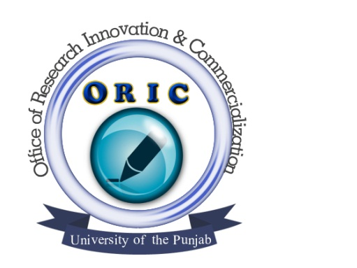

APPLICATION FORM FOR WORKSHOP

- Quantitative Data Analysis using SPSS

Particulars of the applicant (in capital letters):

- Name:
- Father’s name:
- Address:
- Nationality: (a) (b) CNIC No.
- Cell #:
- Organization name:
- E-mail address:

Certificate/Degree | Institution | Board/University
Matric/O Level or equivalent
F.A./F.Sc./A Level or equivalent
B.A./B.Sc.
M.A./M.Sc.
M.Phil
Ph.D.
Any other

- Fee Deposited R.s _________________
Bank challan No.___________________ dated: ____________________

Signature of applicant:

