Course Contents for Subjects with Code: ISE
This document only contains details of courses having code ISE.

Code | Subject Title |  | Cr. Hrs | Semester
ISE-101 | Tafseer-I |  | 3 | I
Year |  | Discipline
1 |  | Islamic Education

Code | Subject Title |  | Cr. Hrs | Semester
ISE-102 | Hadith-I |  | 3 | I
Year |  | Discipline
1 |  | Islamic Education

Code | Subject Title |  | Cr. Hrs | Semester
ISE-103 | Tafseer-II |  | 3 | II
Year |  | Discipline
1 |  | Islamic Education

Code | Subject Title |  | Cr. Hrs | Semester
ISE-104 | Hadith-II |  | 3 | II
Year |  | Discipline
1 |  | Islamic Education

Code | Subject Title |  | Cr. Hrs | Semester
ISE-105 | Seerat un Nabi |  | 3 | II
Year |  | Discipline
1 |  | Islamic Education

Code | Subject Title |  | Cr. Hrs | Semester
ISE-111 | Islamiat / Ethics |  | 2 | I
Year |  | Discipline
1 |  | Botany, Zoology, Mathematics-I,II, Statistics-I,II,III, Chemistry-I,II, Applied Psychology, Business Administration, Commerce, Economics, English, Sociology & Sociocultural Studies, Social Work, Political Science, Physics, Mass Communication, History, Education (Elementary), Education (Secondary), Urdu

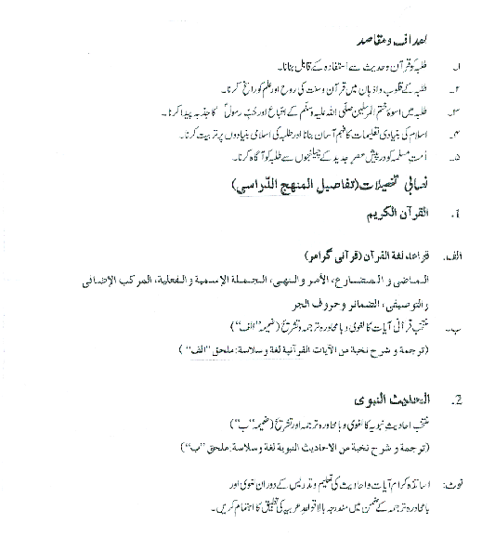
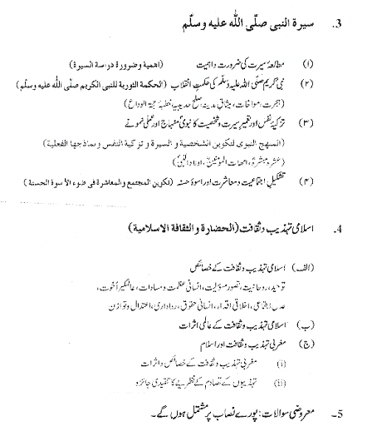

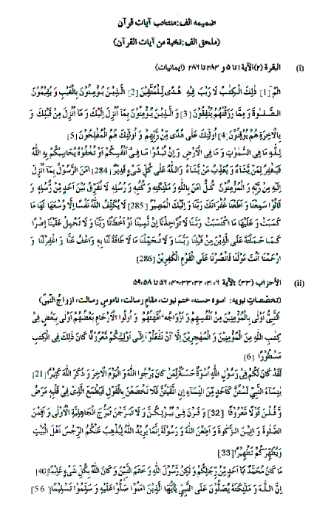
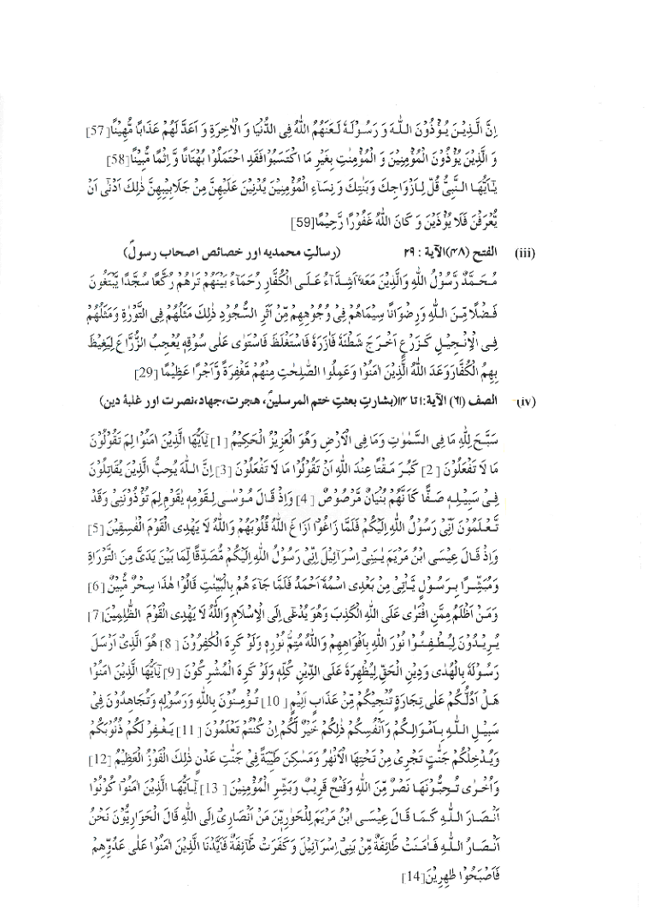
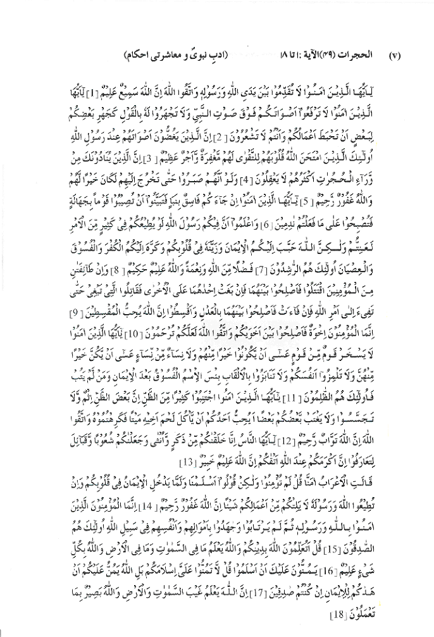
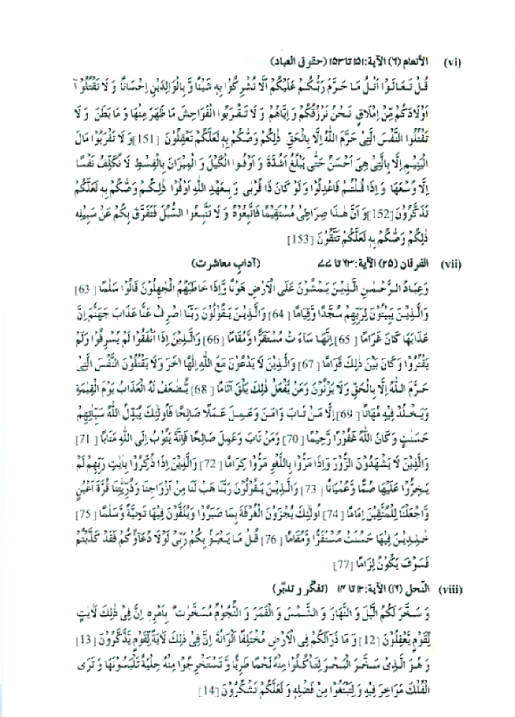

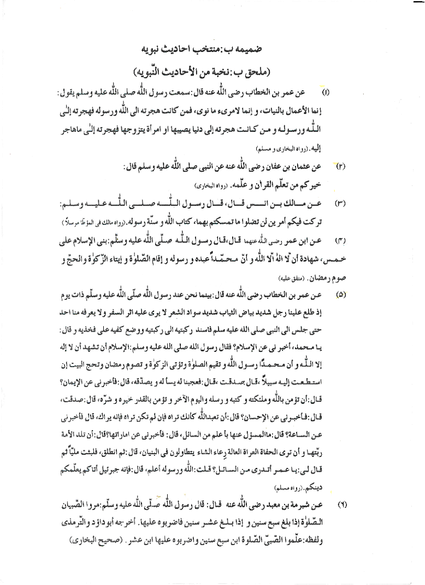
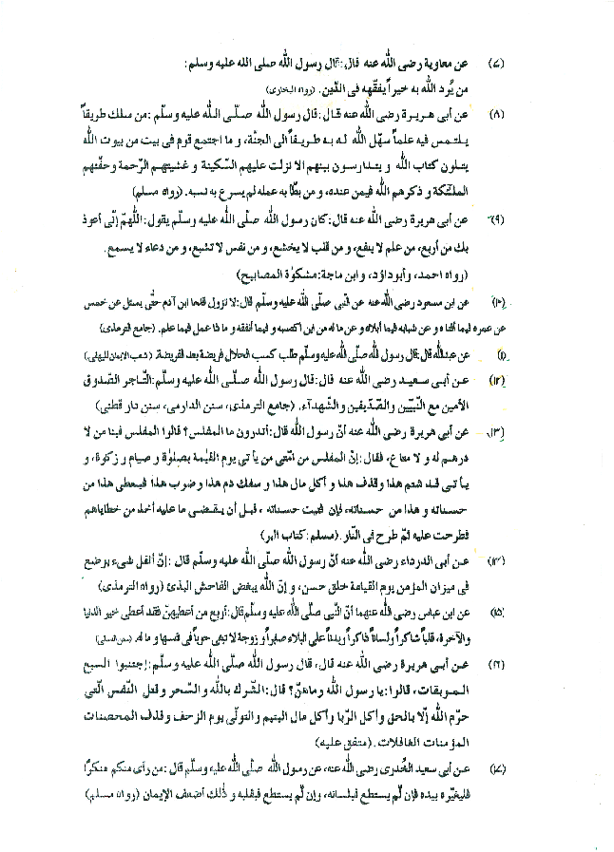
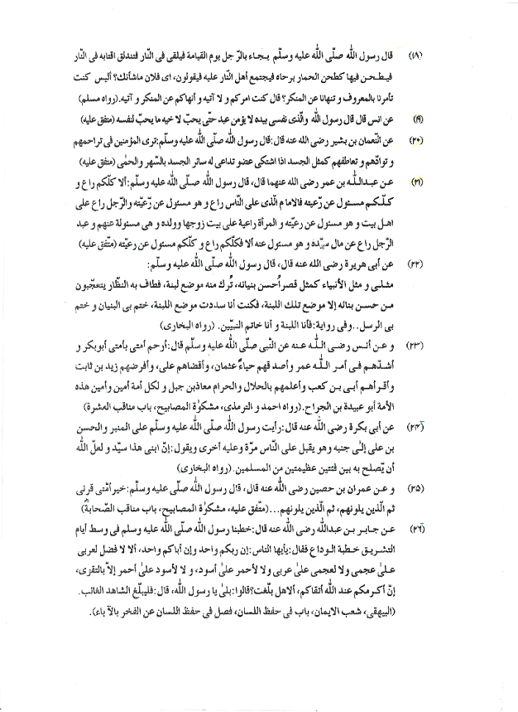
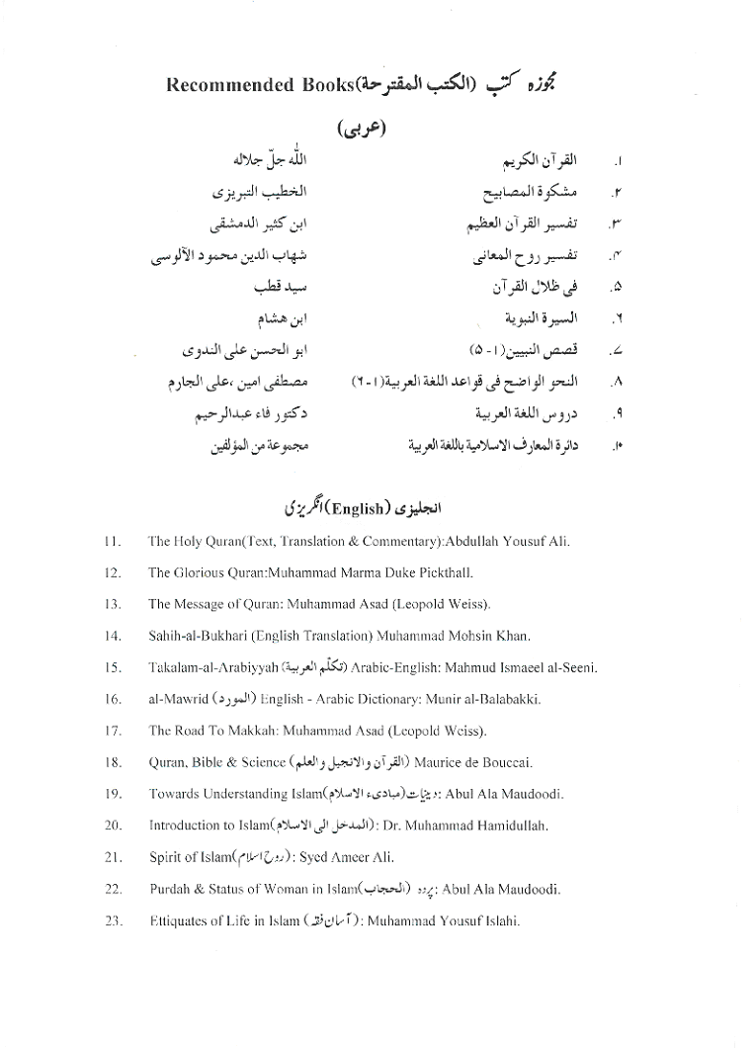
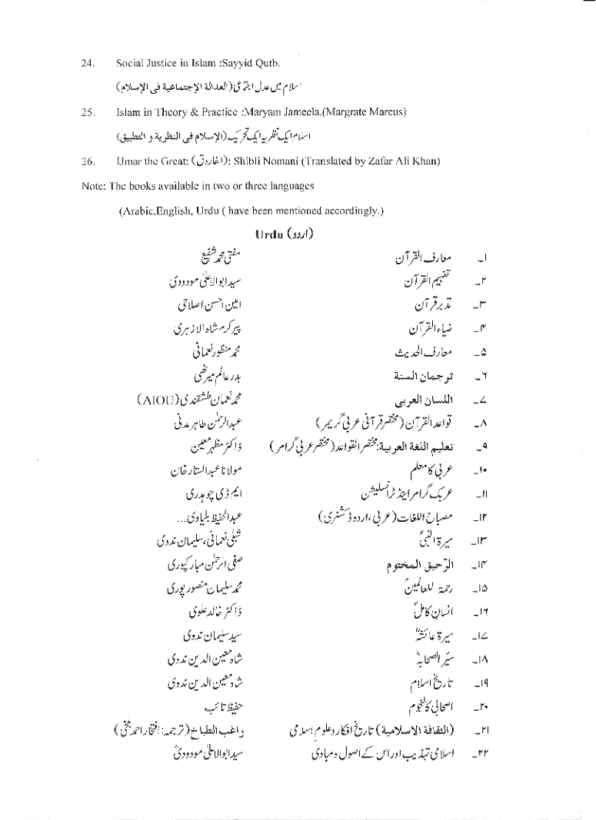
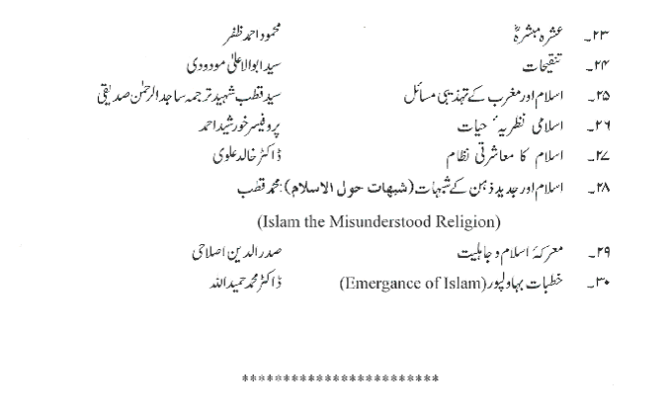
Ethics (for Non-Muslims)
- Definition of Ethics
- Different concepts of Ethics (Ancient and contemporary)
- Types of Ethics
- Good Ethics
- Bad Ethics
- Importance of Ethics in Human Life
- Individual Life
- Family Life
- Social Life
- Importance of Ethics in Economic Life
- Importance of Ethics in Politics
- Ethical Teachings and Values in Different Religions
- Hinduism
- Buddhism
- Zoroastrianism
- Christianity
- Judaism
- Sikhism
- Islam
- Ethical Values of the above Religions
- Truthfulness
- Trustworthiness
- Service to Humanity
- Tolerance, Endurance
- Respect for others
- Cooperation, Mutual Help, selflessness
- Justice (Social Justice, Economic Justice)
- Equality
- Concept of virtue and Evil in different religions.
- Concept of “Flah” in Different Religions.
- Attitude towards other Religions.

Recommended Books:
- J.S. Mackeuzie, A Manual of Ethics
- Harold H.Titus, Ethics for Today
- B.A. Dar, Quranic Ethics
- Hameedullah, Dr. Introduction to Islam
- Ameer Ali Syed, The spirit of Islam

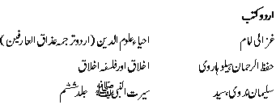

Code | Subject Title |  | Cr. Hrs | Semester
ISE-121 | Islamic Studies-I |  | 2 | I
Year |  | Discipline
1 |  | Information Technology
This course provides a comprehensive knowledge of Islam. It covers the basic beliefs and practices of Islam. This course is intended to familiarize students with a range of the most important Islamic beliefs, practices, and issues. It should equip them to recognize, understand and appreciate the different dimensions of Islam that they will encounter in their practical life. This course will enable the students to perform their worship in the manner prescribed by Allah. It will also make them aware of their duties as Muslims, including what is compulsory, what is permitted and what is forbidden for a Muslim in his day-to-day life. This course will also enable the students to appreciate the beauty and excellence of Islamic moral and social teachings and adopt them as their guidance in life thereby demonstrating values and attitudes necessary for a healthy and balanced lifestyle. The following topics will be covered in this course: Aqeedah, Tawheed, Risalah and Al-Akhira, Tahara, Salah, Sujood as-Sahw, Qadda (making up), Qasr (Shortening) and Jama(Joining), Sawm (Fasting), Salah at-Taraaweeh (The Night Prayer), Zakaah, Hajj, Jihad, Birth, Tehneek , Aqeeqah and Circumcision (Khittaan), Death, The Funeral Prayer, Burial, Food and Dress/Adornment, Male/Female relationship, Social Interaction Between Men & Women, Marriage(Nikah), Rights and Obligations of the Spouses, The Law of Divorce, Inheritance, Major Sins (Kabirah), Crime & Punishment, Islamic Economics & Finance, Contemporary issues, Moral/ Manners / Tazkiyah Nafs, concepts of Taqwa, Tazkiyah, Ihsan, Huqooq ullah and Huqooq ul-Ibad.

Text Book
Dr. Muhammad Hamidullah, Introduction to Islam

Reference Material
• Marwan Ibrahim Al-Kaysi, Morals And Manners in Islam, The Islamic Foundation, Leicester, United Kingdom, 1991.
• Mohammad Yusuf Islahi, Etiquettes of Life In Islam, Markazi Maktabah Islami Publishers, New Delhi, 2003.
• Dr. Abu Ameenah Bilal Philips, The Foundations of Islamic Studies.
• John Esposito, Islam: The Straight Path
• Abul A'la Mawdudi, Al-Jihad Fil Islam
• Dr. Abu Ameenah Bilal Philips, Funeral Rites in Islaam
• Jamal A. Badawi, At-Taharah: Purity And State Of Undefilement
• Abul A'la Mawdudi, Human Rights in Islam
• Abul A'la Mawdudi, Ethical Viewpoint of Islam
• Muhammad Akram Khan, An Introduction to Islamic Economics
• Khurshid Ahmad, Studies in Islamic Economics

Code | Subject Title |  | Cr. Hrs | Semester
ISE-201 | Contemporary Muslim World |  | 3 | III
Year |  | Discipline
2 |  | Islamic Studies

Code | Subject Title |  | Cr. Hrs | Semester
ISE-202 | Fiqh-I |  | 3 | III
Year |  | Discipline
2 |  | Islamic Studies

Code | Subject Title |  | Cr. Hrs | Semester
ISE-203 | Islamic History-I |  | 3 | III
Year |  | Discipline
2 |  | Islamic Studies

Code | Subject Title |  | Cr. Hrs | Semester
ISE-204 | Islamic History-II |  | 3 | IV
Year |  | Discipline
2 |  | Islamic Studies

Code | Subject Title |  | Cr. Hrs | Semester
ISE-205 | Tafseer-III |  | 3 | IV
Year |  | Discipline
2 |  | Islamic Studies

Code | Subject Title |  | Cr. Hrs | Semester
ISE-206 | Islam and Modern Political Thoughts |  | 3 | IV
Year |  | Discipline
2 |  | Islamic Studies

Code | Subject Title |  | Cr. Hrs | Semester
ISE-221 | Islamic Studies-II |  | 2 | IV
Year |  | Discipline
2 |  | Information Technology
The objective of this course is to impart an understanding of the fundamental principles and teachings of Islam through study of selected verses of the Quran and Prophetic Sayings. It also includes the important facets of the Prophet’s life and salient features of Islamic Civilization. It will provide appreciation of other prominent religions, systems of ethics and cultures to prepare students to survive in international and multicultural work place. This course introduces students to the basic teachings of Islam so that they can understand the rationale behind Islamic beliefs and practices. The following topics will be covered in the course: Basic sources of teaching, beliefs and their impact on human life, obligation to God, obligations to fellow human beings, and other related issues.

Text Book
Dr. Muhammad Hamidullah, Introduction to Islam
Reference Material
Marwan Ibrahim Al-Kaysi, Morals And Manners in Islam, The Islamic Foundation, Leicester, United Kingdom, 1991.
Mohammad Yusuf Islahi, Etiquettes of Life In Islam, Markazi Maktabah Islami Publishers, New Delhi, 2003.
Dr. Abu Ameenah Bilal Philips, The Foundations of Islamic Studies.
John Esposito, Islam: The Straight Path
Abul A'la Mawdudi, Al-Jihad Fil Islam
Dr. Abu Ameenah Bilal Philips, Funeral Rites in Islaam
Jamal A. Badawi, At-Taharah: Purity And State Of Undefilement
Abul A'la Mawdudi, Human Rights in Islam
Abul A'la Mawdudi, Ethical Viewpoint of Islam
Muhammad Akram Khan, An Introduction to Islamic Economics
Khurshid Ahmad, Studies in Islamic Economics

Code | Subject Title |  | Cr. Hrs | Semester
ISE-301 | Hadith-III |  | 3 | V
Year |  | Discipline
3 |  | Islamic Education
Code | Subject Title |  | Cr. Hrs | Semester
ISE-302 | Fiqh-II |  | 3 | V
Year |  | Discipline
3 |  | Islamic Education
Code | Subject Title |  | Cr. Hrs | Semester
ISE-303 | Islam & Modern Social Thought |  | 3 | V
Year |  | Discipline
3 |  | Islamic Education

Code | Subject Title |  | Cr. Hrs | Semester
ISE-304 | Tafsir-IV |  | 3 | VI
Year |  | Discipline
3 |  | Islamic Education

Code | Subject Title |  | Cr. Hrs | Semester
ISE-305 | History & Principles of Hadith |  | 3 | VI
Year |  | Discipline
3 |  | Islamic Education

Code | Subject Title |  | Cr. Hrs | Semester
ISE-306 | Dawa o Irshad |  | 3 | VI
Year |  | Discipline
3 |  | Islamic Education

Code | Subject Title |  | Cr. Hrs | Semester
ISE-307 | Islamic Jurisprudence & its History |  | 3 | VI
Year |  | Discipline
3 |  | Islamic Education

