OFFICE OF THE TREASURER
Procurement Wing – Accounts Department
2nd Floor, Admin Block, Quaid-e-Azam Campus, Lahore.
Tel: 042-99233105, Fax: 042-35863230 Email: pu.pw@pu.edu.pk

Tender Fee: Rs.500/-

BID DOCUMENTS

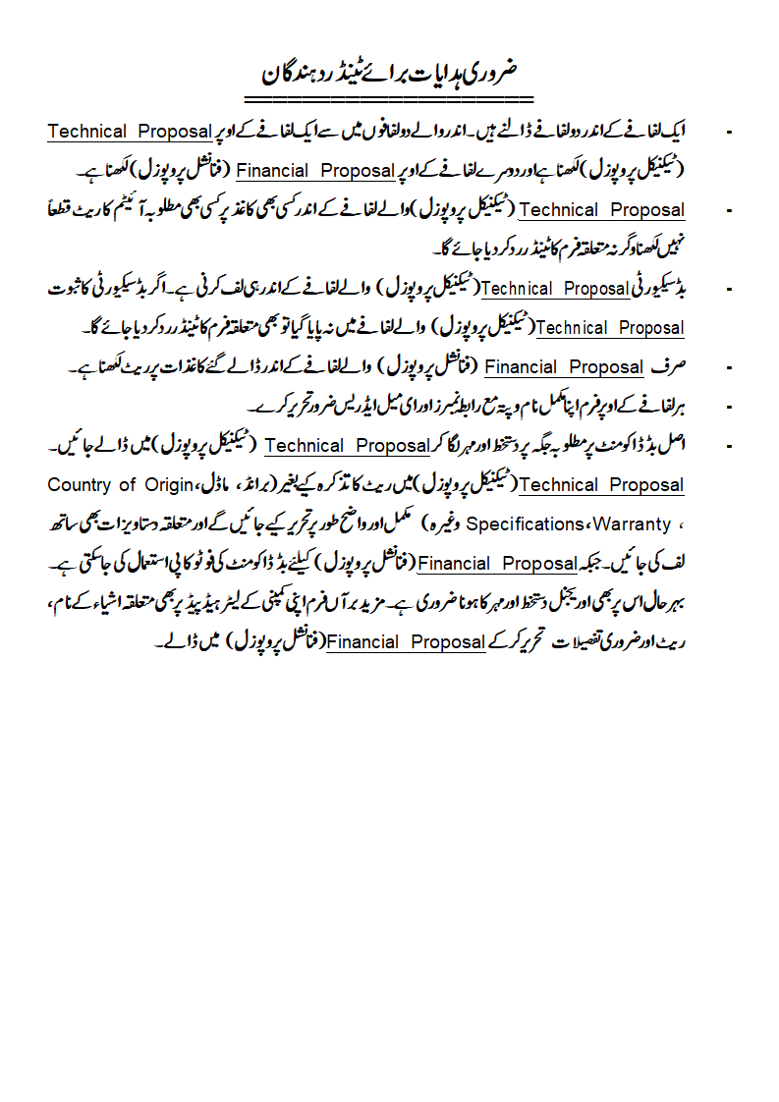
Selected bids are invited on Single Stage Two Envelopes (Technical & Financial) Basis by University of the Punjab from the manufacturers or their concerned authorized distributors / Authorized Partners / dealers, firms etc. registered with GST & NTN and PRA (if applicable), for the procurement of below mentioned “Repair of Student Chairs for Punjab University Gujranwala Campus. Single Envelope Containing Two Separate Envelopes which must be marked as “Financial Proposal” & “Technical Proposal. (Only FOR (in Pak Rupees Only) Basis)

Sr. No. | ITEMS DESCRIPTIONS  Minimum Required Specifications or equivalent | Qty. | Picture / Required Design | Unit Price | Total Price | Budget Estimates  (PKR Million)
 | Seat and Back for the Repair of Student Chair  - Seat 18×18 In Wooden frame with thickness of 1 inch. Back seat 8×16 In Wooden frame  - Foam seat thickness 2 inches with basic material fillin  - Fabric used for the both seat & back is of high quality joot or industrial material  Sample: A sample chair is available at the  campus. | 500 Nos. | 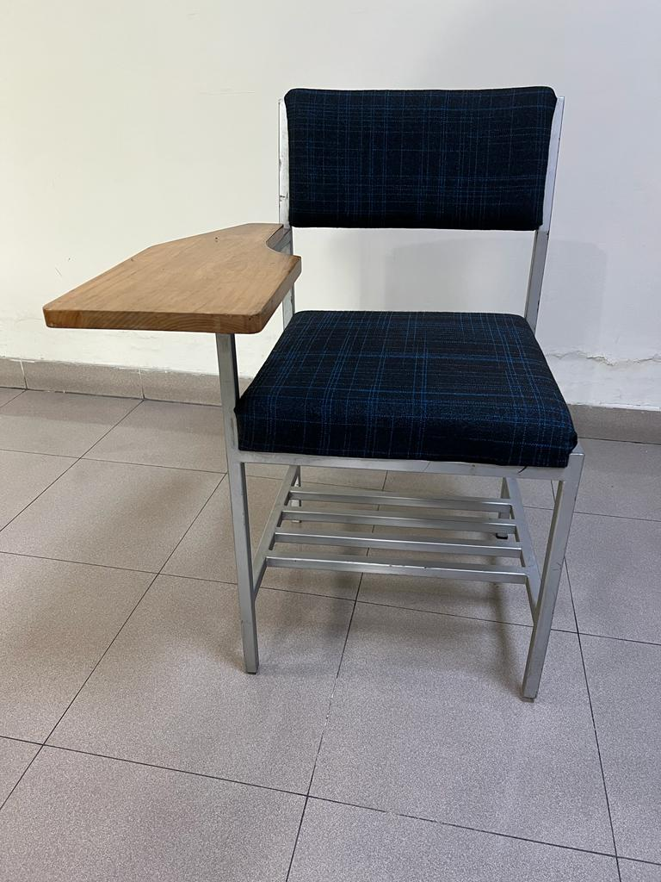

Total Amount / Bid Value:
Bid Security (Original) Amounting to Rs.27,000/- in the form of Demand Draft / Bankers Cheque / CDR / Bank Guarantee Must be Attached with the Technical Bid:
Firm’s stamp and case No. must be marked on back of Bid Security.
Special Note
The required Bid Security must be attached with Technical Bid, otherwise, bid will be rejected.
Only one brand / model / option is allowed to quote against each option. In case, more than one option with different brands / models with different prices have been quoted against one option, the bid will be rejected as a whole
The mentioned specifications and the terms & conditions of the bid documents constitute the bid evaluation criteria. The financial bids of technically accepted bidders (whose quoted item / model / brand will be according to the minimum required specifications and who will comply with the terms and conditions of the bid documents or in case of sample requirement, whose sample will be passed by the technical committee) will be opened publicly at a time to be announced by the Procuring Agency. The financial bids of the bidders found technically non-responsive shall be returned un-opened to the respective Bidders.
If demanded by the technical committee, the vendor will be bound to provide the sample of the required item / items to the technical committee in accordance with the specifications mentioned in the bid document. In case of non-compliance, the bidder will be rejected in the concerned item / items. All the allied charges relating to sample will be borne by the vendor at his own expense and there will be no responsibility / liability at the end of University.
Departmental Technical / Evaluation Committee will have right to reject the sample, if, the sample is not according to the specifications and terms & conditions mentioned in the bid documents.
In case of the item / items for which the technical committee does not feel the requirement of sample, the vendor will be bound to provide the supply of concerned item / items in accordance with given specifications & approved sample according to quoted rates.
In case, decision is made on the basis of samples, the decision of Technical Committee will be final (Knock off clause).

Note:

1. An Affidavit / Undertaking on Stamp Paper of Rs.20/- (minimum) must be submitted by the bidder undertaking that:

(a) The firm has not been blacklisted in the past on any ground by any Government (Federal, Provincial), a local body or a public sector organization and no litigation is underway on account of blacklistment process. In case the bidder has been disqualified or blacklisted earlier in the past by any public sector organization, detail concerning the period of such disqualification/ blacklistment, cause of such embargo and eventual result/ latest status shall be mentioned by the bidder. On account of submission of false statement or concealment of fact, the Bidder shall be disqualified forthwith, if contract has not been executed and blacklisted, if the contract has been executed.

(b) 0.25% stamp duty would be furnished by the successful bidder against the amount of the value of purchase order as levied by the Government after the issuance of purchase order.

2. The University shall initially open only the envelopes marked as “TECHNICAL PROPOSAL” in the presence of Bidders’ representatives who choose to be present, at the time of bid opening. However, the envelope marked as “FINANCIAL PROPOSAL” shall remain unopened and shall be retained in safe custody of the University till completion of the technical evaluation process. Financial Details (Rates) must not be mentioned in the technical bid otherwise the bid will be rejected.

3. The over writing / cutting in the rates / specifications etc. is not allowed. In case of over writing / cutting, the bid for the said item will be rejected or the decision of University will be final & applicable which will not be challengeable anywhere.

4. Complete brochures / supporting documents of the quoted brands / items must be enclosed along with the bid document, where applicable.

5. Technical Specifications minimum Equivalent or Higher will be applicable. Soft copy must be provided in form of (MS Word) CD along with bid, if applicable.

6. Signature & stamp of the bidder is essential at the proper place given at the end of bid document.

7. Warranty details must be mentioned by bidder.

8. The repair & maintenance of the placed equipment (if required) will be the responsibility of successful bidder / company.

TERMS & CONDITIONS:
1. Bid should be addressed in the name of Treasurer, University of the Punjab and reach in this office (Procurement Wing) by 27.09.2022 at 10:30 (a.m.).

2. The Tender Opening Committee will open the bids on same date at 11:00 (a.m.) in the presence of bidders, who wish to attend. In case of bid submission / opening date falls on the public holiday, the submission / opening date will be next working date.

3. Bid received after due date/time will not be accepted under any circumstances.

4. The bid should be submitted along with 2% Earnest Money Demanded (EMD) of the estimated price in the form of Demand Draft, Bankers Cheque, or CDR in favor of the Treasurer, University of the Punjab payable at Lahore to be issued from any enlisted bank with State Bank of Pakistan. No bid shall be acceptable without EMD. The said EMD of rejected bidder / bidders will be released after final decision. However, the EMD of successful bidder / bidders will be retained until the completion of job successfully as per work order. In case of LC, the 2% EMD can be get released after submission of 10% performance security. In case of Rate Contract, the 2% bid security will be retained until the expiry of contract period. Moreover, the CDR of technically non-responsive bidders can be got released after decision of the tender during working hours between 03:00 pm to 04:00 pm from Tuesday to Thursday after the submission of request on the letter head pad of the concerned firm to the competent authority. The concerned CDR will be physically handed over to the authorized person of the firm and the authorized person must have copy of CNIC and authority letter while receiving the CDR(s).

5. Bid shall remain valid for 120 days from the date of opening the bid.

6. In case of Rate Contract, the Rate Contract shall be placed with only registered / reputed manufacturers / authorized distributors of foreign manufacturers who are authorized for supplying the stores, so fresh registration/authorization certificate is required along with bid subject to the reasonability of rates, company profile, past experience, professional skills, credibility of the firm etc. However, if some un-authorized firm bearing excellent goodwill, company profile, past experience, professional skills, credibility of the firm etc. with reasonable price that can be considered subject to the recommendations of concerned committee.

7. The supply should be executed promptly within delivery period mentioned in Purchase Order. In case, the firm fails to supply the stores within stipulated period, University of the Punjab reserves the right not to accept the supply, in part or in full and to claim liquidated damages @ 2% per Month (0.06% per day) subject to a maximum of 10% of the total value of stores ordered.

8. The vendor should ensure that no other Govt. organization is being offered / benefited more than this discount. If the same is found at any stage recovery will be made accordingly.

9. For any Damages/Shortage during transit, bidder will be responsible & the same must be replaced within maximum 7 working days.

10. In case the supplies are warranty items, 10% Security of the ordered value will be deducted at the time of payment or the vendor can himself submit 10% performance security in the form of CDR / banker’s cheque / bank guarantee having minimum expiry date in accordance with the warranty period of the items etc. In case of warranty, the amount of Security will be held by the University till warranty period and the said amount will be released upon the satisfactory report of end user.

11. The supply will be checked by the Technical Committee / representative of the department, if so desired.

12. The technical committee shall determine to its satisfaction whether the bidder that is selected as having submitted the lowest evaluated responsive bid is qualified to perform the Contract satisfactorily.

13. The determination shall take into account the Bidder’s financial, technical, and production capabilities. It shall be based upon an examination of the documentary evidence of the Bidder’s qualifications submitted by the Bidder, as well as such other information as the Technical Committee / University deems necessary and appropriate.

14. The Technical Committee / University, at any stage of the procurement proceedings, having credible reasons for or prima facie evidence of any defect in Supplier’s capacities may require the Suppliers to provide information concerning their professional, technical, financial, legal or managerial competence.

15. The Technical Committee / University shall disqualify or blacklist a Bidder if it finds, at any time, that the information submitted by him concerning his qualification as Supplier was false inaccurate or incomplete, or otherwise to be indulging in corrupt and Fraudulent practices.

16. The Bidder should quote the prices of goods according to the technical specifications. The specifications of goods, different from the demand of enquiry, shall straightway be rejected.

17. The Bidder is required to offer competitive price. All prices must include relevant taxes and duties, where applicable. If there is no mention of taxes, the offered / quoted price shall be considered as inclusive of all prevailing taxes/duties. The benefit of exemption from or reduction in the GST or other taxes, if granted at any stage of procurement, shall be passed on to the University.

18. Prices offered should be for the entire quantity demanded; partial quantity offers shall straightaway be rejected. Conditional offer shall also be considered as non-responsive Bidder. Where prices are to be quoted in package, all items mentioned in the package shall be quoted in the offered prices. Non-mentioning of price of each item of the package being non-responsive shall be rejected straightaway.

19. The Supplier/ agent shall have to produce letter of authorization from Manufacturer and in case of Manufacturer, documentary proof to the effect that they are the original Manufacturer of the required goods shall be provided.

20. National Tax Number (NTN), General Sales Tax Number, Professional Tax (if applicable) and registration certificate with PRA (if applicable) with documentary proof shall have to be provided by each Bidder in the tender.

21. During evaluation of the bids, the University may, at its discretion, ask the Bidder for a clarification of its bid. The request for clarification and the response shall be in writing, and no change in the prices or substance of the bid shall be sought, offered, or permitted.

22. In the financial bids (at the time of opening the financial proposal) the arithmetical errors shall be rectified on the following basis. If there is a discrepancy between the unit price and the total price that is obtained by multiplying the unit price and quantity, the unit price shall prevail, and the total price shall be corrected. If the Bidders/Suppliers do not accept the correction of the errors, its bid shall be rejected. If there is a discrepancy between words and figures, the amount in words shall prevail.

23. In case, the blacklistment of the firm is to be pursued, the blacklisting procedure will be adopted as per PPRA rules.

24. In case the vendor fails to complete the job or provide substandard articles, or withdraw his offer for any reason, the EMD will be forfeited.

25. The material must be supplied in one lot. Part supplies generally will not be acceptable. Moreover, the payment will be made after the job has been accomplished in all respects quite in accordance with the work order. However, in special cases, partial supply / partial payment is allowed subject to the approval of competent authority.

26. Force majeure clause is acceptable as defined under sales of goods & contract Act.
27. The procurement process will be accomplished in accordance with the PPRA Rules. In case, any of the mentioned clause of the bid documents is in conflict with the PPRA rules, the PPRA rules will prevail upto the extent of that conflict.

28. No advance payment will be made in favor of tender awarded firm.

29. Normally the payment will be made within 14 days after receipt of supplies & found in order in quality and quantity and submission of claim / bill with complete supporting documents.

30. The supplies must be confirmed to the specification of supply order and free of defects in all respects. If the same is found defective, the same must be replaced immediately free of charge at University of the Punjab, Lahore.

31. All the disputes under the Rate Contract will be settled by the Main Purchase & Indent Committee, University of the Punjab and will be binding on vendor.

32. The competent authority reserves the rights to increase or decrease the quantity as per actual requirement / availability of funds.

33. It is the intention of the authority to make the selection of vendor(s) as fair, transparent objective and efficient as possible. The Technical Committee will adopt the approach outlined below to achieve this objective.

(i) Review all quotations to ensure that the minimum technical specifications are met. Any bid which fails to meet the defined minimum specifications will be disqualified.

(ii) Evaluate the proposed products that are above the minimum requirements. The evaluation procedure adopted is based on the weighting of all requirements and scoring the vendor’s responses appropriately.

(iii) Good will / past experience/ history of the firm will be considered while evaluating the bids.
(iv) Compliance to the instructions terms and conditions etc., given in bidding documents.

34. The firm will be bound to provide / ensure quality after sales services during the warranty period. Otherwise, disciplinary action will be taken under the rules which can include forfeiture of bid security/ black listing/ disqualification for the participation in any bidding process in future or both of them.

35. The end user on behalf of the University shall notify the supplier in writing / through telephone immediately of any defect that occurs during the warranty period. On receipt of such intimation/notification within the warranty period, the supplier shall attend the emergency / breakdown call within a maximum of 06 working hours.

36. All the expenses for the above remedial measures including the repair / replacement if so required shall be borne by the supplier. In case the fault has occurred as direct consequence of undesirable condition i.e. electricity or temperature, the supplier shall inform the buyer for taking corrective measures prior to the commencement of the remedial activity.

37. Wherever a brand has been specified, equivalent will be entertained subject to technical evaluation according to PPRA Rules.

38. The rates should be quoted after allowing rebates / discounts, if any but including transportation, delivery at site, commissioning, packing charges, forwarding and all taxes.

(i) If the supply is taxable, the rate must be quoted Inclusive of all Taxes.
(ii) If the supplies are exempted of taxes, the exemption certificate/ comprehensive supporting documents must be provided along with the bid.

(iii) If the PST duly imposed by the Govt. of the Punjab is applicable on the quoted job, then the rate must be quoted after including PST.

39. While quoting the rates of required/specified supplies, its make & made/brand should be written against each. The rates should be quoted only in Unit / Per Kg. / Per Litter / Pack Each according to the nature of the quotations / bids.

40. Competent authority / University of the Punjab, has full unchallengeable rights for formal approval / rejection of bids or overall the purchase case.

41. In case of supply on FOR basis, the supply shall be accepted subject to the condition of final and unchallengeable approval of the Purchase / Inspection Committee of the University, at the destination.

42. Prior to the detailed evaluation, the University shall determine the substantial responsiveness of each bid to the bidding documents. A substantially responsive bid is one, which conforms to all the terms and conditions & specifications of the bidding documents without material deviations. Deviations from, or objections or reservations to critical provisions shall be deemed to be a material deviation for technical proposals. The University’s determination of a bid’s responsiveness is to be based on the contents of the bid itself without recourse to extrinsic evidence.

43. If a bid is not substantially responsive, it shall be rejected and will not be accepted/ entertained for detail evaluation.

44. The bid amount will be quoted by the vendor along with this certificate:

Assistant Treasurer (Procurement)
I / We have read all the above Bid Document’s instructions and submit bids/rates in conformity / compliance with the above given terms and conditions.
______________________________________
Signature & Stamp of Supplier/Bidder/Vendor

________
Dealing PersonAsstt./Deputy Treasurer

