BOOK REVIEW
Title:
Income Tax Law Plus Practical Problems with Solutions: 2006-07
Authored By:

Principal, Hailey College of Banking & Finance, University of the Punjab, Lahore Pakistan, Email:kamjadsaeed@yahoo.com www.kamjadsaeed.edu.pk
Member Governing Council, International Federation of Accountants (IFAC), New York (1997-2000), President, South Asian Federation of Accountants (SAFA) (1997), President, Institute of Cost and Management Accountants of Pakistan (1997-2000), President, Association of Management Development Institutions of South Asia (AMDISA) (1993-96), Pro Vice-Chancellor University of the Punjab, Lahore (1994-1996), Founder Director, Institute of Business Administration (IBA), University of the Punjab, Lahore (1973-1996).

Published By:
M. Azeem Academy 22-Urdu Bazar, Lahore tel: (042) 723144- Price:150. pp 390.

Pakistan is in search of a fiscal policy which can ensure an accelerated tempo of domestic resource mobilization to not only meet the current expenditure at federal level but also contribute substantially toward financing annual development plans. The federal budget for 2006-07 forecasted a revenue deficit of Rs. 175 billion and the federal ADP 2006-07 of Rs. 435 billion which is dependent on 55% on external assistance. In this backdrop, there is an urgent need for Pakistan to help develop innovative measures to reverse the above trends and give Pakistan a financially comfortable look.
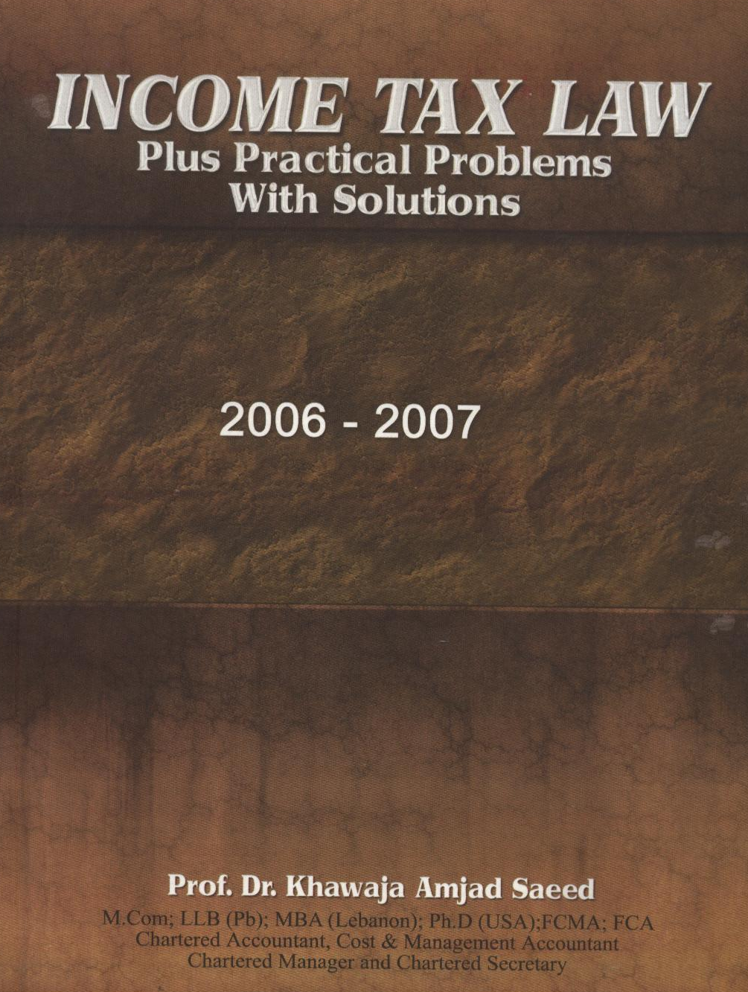
The Federal Government has major sources of domestic revenues for 2006-07 namely, indirect tax (Rs. 569 billion-53%), direct taxes-mainly income tax (Rs. 272 billion- 25%), non-tax revenue (Rs. 242 billion-22%).
The book under review relates to income tax. Based on available statistics there are around 1.4 million income tax payers in a population of 160 million of people in Pakistan. This situation requires immediate attention as the untapped number of income tax payers I said to be around five million. The Central Board of Revenue is ever keen to expand the base. Strong logistics are needed to achieve the above goal and improve tax-GDP ratio. The earlier this is done the better.
In this background, Prof. Dr. Khawaja Amjad Saeed, an eminent professional accountant turned excellent academician, has written book entitled “Income Tax law Plus Practical Problems with Solutions” (Edition 2006-07). This magnificent treatises has the following redeeming features:
- It consists of two parts. The first part contains lucid and easy to understand commentary on topics such as: Introduction, Capital and Revenue, Charge of Tax, Exemptions and Tax Concessions, The Finance Act, 2006, Administration, Appeals, heads of Income: Salaries, Income from Property, Income from Business, Income from other Sources, head of Income: Capital Gains, Procedure, Provisions Governing Persons, Tax Accounting, Losses and, Miscellaneous topics.
- In the second part, the book contains fifty five (55) questions with model solutions covering assessment of individuals, AOPs, Companies and Set-off and Carry-forward of Losses.
- Amendments introduced through the Finance Act, 2006 into the Income tax Ordinance 2001 have been duly incorporated into the book.
- Easy to comprehend notes on the Finance Act, 2006 issued by the Central Board of Revenue have also been included in the book.
Prof. Dr. Khawaja Amjad Saeed is a well acknowledged scholar in Pakistan and abroad. His services to the nation are well spread over forty nine (49) years-eight (8) years in the Corporate World and forty (41) years in teaching, training, management development, research, consulting and HRM/HRD. He has authored over thirty books which have served diversified reading community at home and abroad.
The above book will be beneficial to students of business and public administration (MBA/MPA), commerce (B.Com/M.com), Banking & Finance (BBA/MBA), Insurance & Risk Management (BBA/MBA) MBE, BBIT, MBIT, bankers, insurance and business executives. Indeed this is an excellent effort to explain the legal provisions of the income Tax Ordinance, 2001. It is hoped that stakeholders will greatly benefit from it. Laypersons can easily comprehend the working of Income Tax law in Pakistan by reading this book.
The book is a logistical support to expanding income tax payers base in Pakistan and the author deserves special appreciation in this respect.
We congratulate the author and earnestly hope that he will continue this noble effort to serve the reading community with his writings and thus pave the way for managerial revolution in Pakistan.

