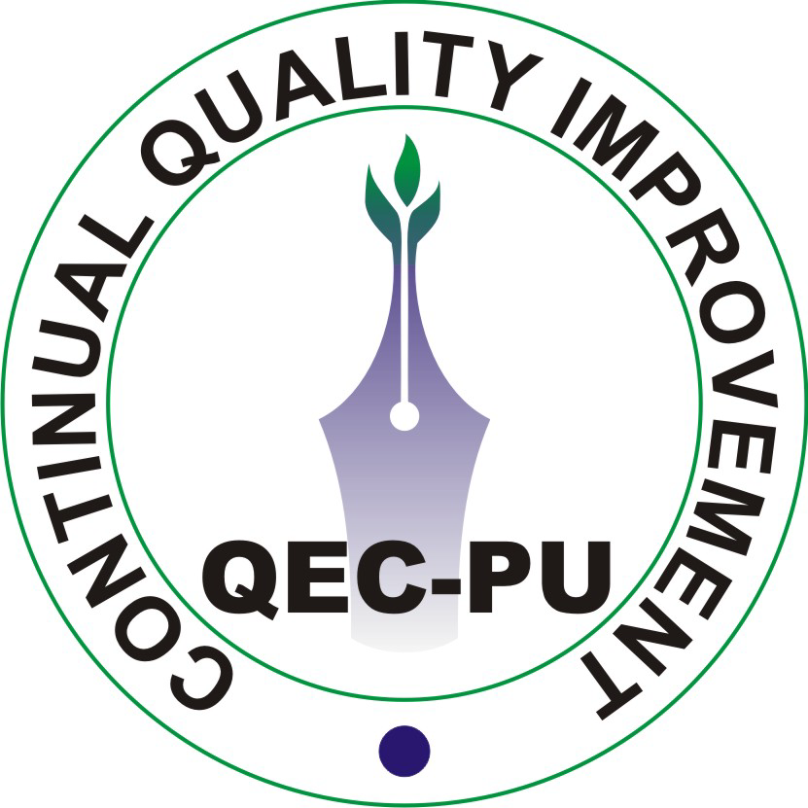 | QUALITY ENHANCEMENT CELL  University of the Punjab, Lahore.
Ref. No: 111 / QEC |  | Date: 01-07-2010

Dean,
Faculty of Arts & Humanities,
University of the Punjab,
Lahore.

Subject: Minutes of Visit to the Faculty of Arts & Humanities for Expediting Self Assessment Activities.

Date: 28-06-2010 (Monday)
Venue: Committee Room of Faculty of Arts and Humanities, University of the Punjab.
In Attendance:
- Prof. Dr. Qalb-i-Abid (Dean Faculty of Arts & Humanities)
- Prof. Dr. Aamir Ijaz (Director QEC)
- Dr. Nasir Saeed Butt (Quality Assurance Advisor IQTM)
- Dr. Farzand Masih (Director Department of Archaeology)
- Ms. Saira Riaz (Department of French)
- Mr. Faraz Anjum (Department of History)
- Mr. Rizwan ullah Kokab (Pakistan Study Centre)
- Mr. Muhammad Abdullah (Deputy Director QEC)
- Mr. Muhammad Naeem (Data Analyst QEC)
Not in attendance:
- Department of English Language & Literature
- Department of Philosophy
- Centre for South Asian Studies
- College of Arts & Design
Proceedings:
- Prof. Dr. Aamir Ijaz (Director QEC) briefed the participants about the purpose of meeting and told the house that implementation of self assessment manual (SAM) is necessary for the improvement of students learning and to achieve the expected objectives and outcomes. The participants were also briefed about the latest status of SAM in Faculty of Arts & Humanities and their progress w.r.t Quality Assurane during the last quarter (Table.1) (Department of Archaeology, Department of French, Department of History, Pakistan Study Centre, College of Arts & Design, Department of English Language & Literature, Department of Philosophy & Centre for South Asian Studies). At the end of his presentation, he said that hopefully all the departments under Faculty of Arts & Humanities will complete their self assessment soon.
Department | PTs formed | SAR received | SAR Sent back for Changes | SAR received after Improvement | Audit Completed | Executive Summary prepared | Implementation Plan
Department of Archaeology | √ | √ | √ | x | x | x | x
Department of English Language & Literature | √ | √ | √ | - | √ | √ | √
Department of French | √ | x | x | x | x | x | x
Department of History | √ | x | x | x | x | x | x
Department of Philosophy | √ | x | x | x | x | x | x
Centre for South Asian Studies | √ | √ | √ | x | x | x | x
Pakistan Study Centre | √ | √ | √ | √ | x | x | x
College of Arts & Design | √ | √ | √ | x | x | x | x
(Table.1)
- Dr. Nasir Saeed Butt suggested that the participants can assess themselves through SAR and give numbers/marks in rubric form (statistics) to judge their standing. In addition to this all survey forms/performas are very important and must be filled in the SAR.
- Dr. Aamir Ijaz clarified that only survey forms & implementation plan will be sent to HEC and not SAR; which would help to get funds from HEC for Research Project and to overcome the weaknesses and shortcomings of individual department.
- Prof. Dr. Qalb-i-Abid informed the participants that it will be difficult in future for any faculty/department to get funds from HEC until that particular faculty/department completes/fulfils its self assessment procedure. Moreover, he said that people think that this is only paper work and therefore, they underestimate its importance. At the end he emphasized that the self assessment work must be expedited.
- Dr. Farzand Masih of department of archaeology said that SAM leads to improvement. Initially, there is a need to understand SAM thoroughly and improvement shall follow.
- Representatives of department of French and History committed to expedite SAR activities.
- The meeting ended with the vote of thanks from Dr. Aamir Ijaz.

(Prof. Dr. Aamir Ijaz)
Director, QEC

cc:
- Higher Education Commission (HEC)
- Secretary to Vice Chancellor, University of the Punjab.
- Department of Archaeology
- Department of English Language & Literature
- Department of French
- Department of History
- Department of Philosophy
- Centre for South Asian Studies
- Pakistan Study Centre
- College of Arts & Design.

