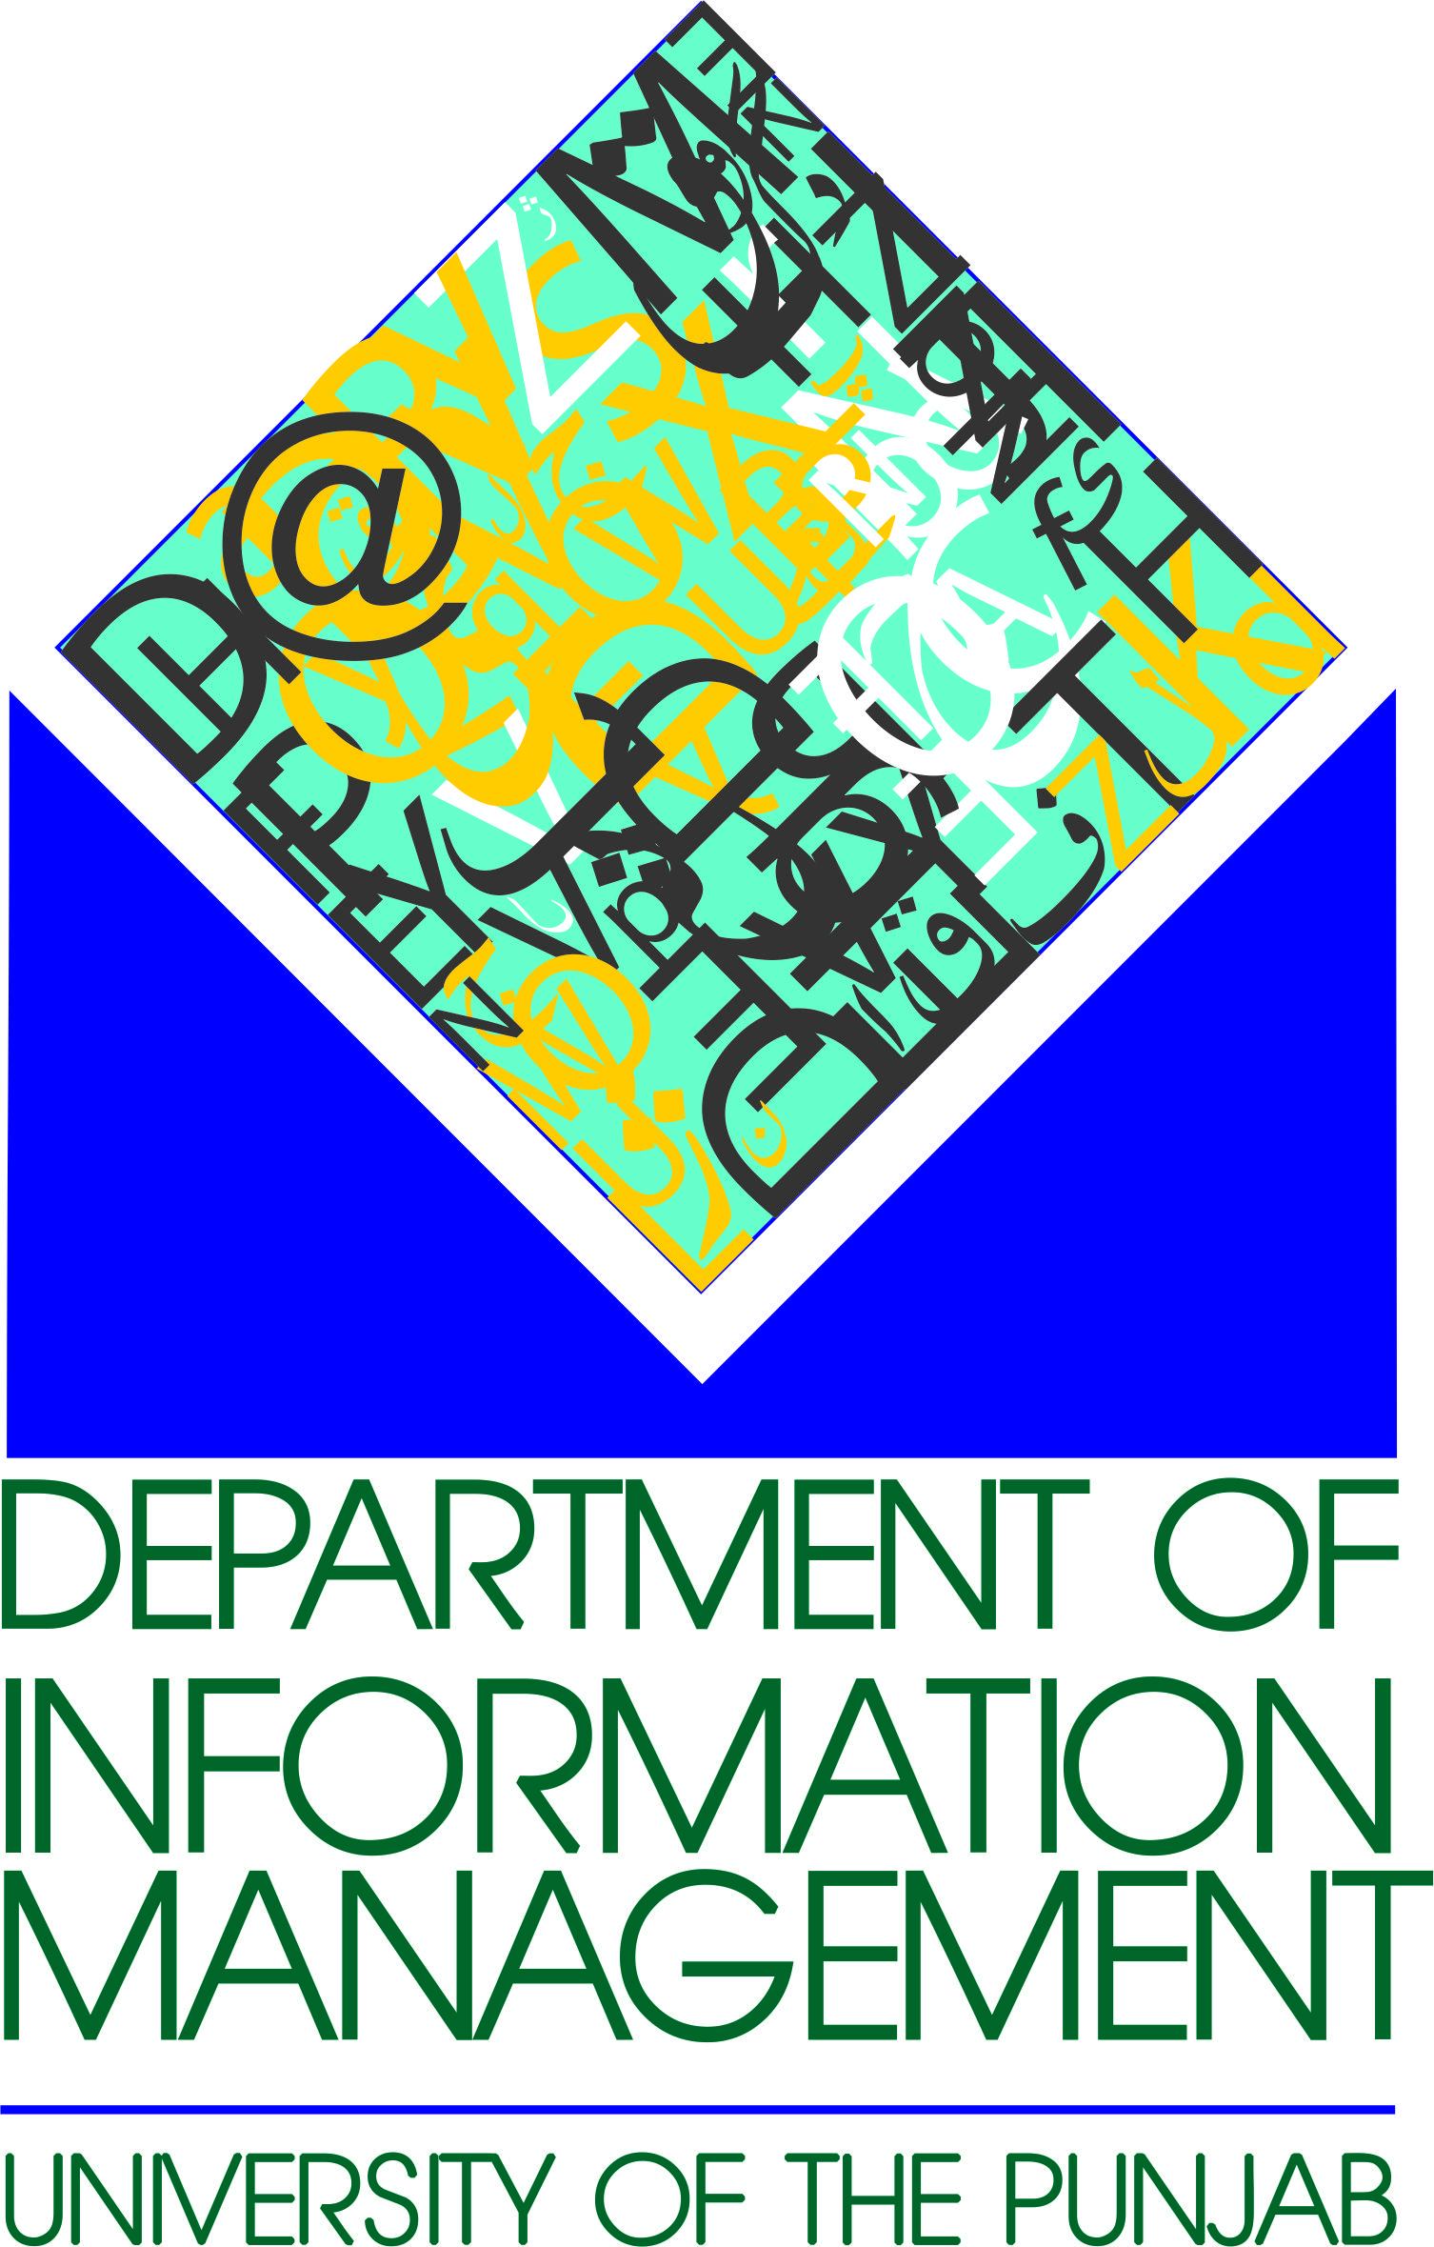

________________________

________________________

________________________

Subject: Invitation to Participate in ICIML 2018

You are cordially invited to participate in 2nd International Conference on Information Management and Libraries (ICIML2018) 10th-12th October 2018 at Department of Information Management, University of the Punjab Lahore-Pakistan. The theme of the conference is “Leading for transformation: Preparing information and library professionals”.
Regarding ICIML, it is 2nd conference which the oldest school in Asia is going to organize after tremendous success of ICIML centenary conference in 2015, which gathered around 600 participants, three keynote speakers, 10 invited speakers, best practices and papers from various parts of the globe.
There will be no liability on the part of organizers regarding the cost of your trip including travel cost, accommodation and registration.
Please feel free to contact for general inquiries at iciml@pu.edu.pk or nosheen.im@pu.edu.pk and for registration at amara.im@pu.edu.pk.
Looking forward to seeing you in Lahore!
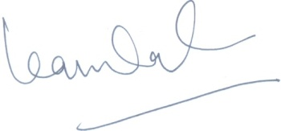

Prof. Dr. Kanwal Ameen
Chair, ICIML 2018
Director, External Linkages

