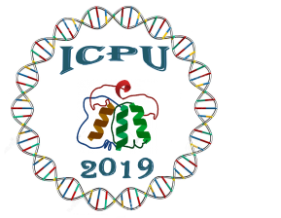
International Conference of Punjab University 2019
Recent Innovations in Molecular Sciences
November 06-08, 2019

Registration Form
Deadline for Early Bird registration is October 20, 2019

Full Name with Title: __________________________________________________________
Designation: __________________________________________________________
Institution: __________________________________________________________
Address: ___________________________________________________________
___________________________________________________________
Phone: ________________________ Fax: _______________________________
E-mail: ___________________________________________________________
Participant category: Student Participant Faculty
Foreign Delegates Non-Academic Participant
Types of Presentations: Oral Presentation Poster Presentation
 | Early Bird Registration  (until October 20, 2019) | Regular/ Onsite Registration  (after October 20, 2019)
Students* | PKR. 2500 | PKR. 3000
Faculty | PKR. 4000 | PKR. 5000
Nonacademic participants | PKR. 6000 | PKR. 7000
Foreign delegates | USD 300 | USD 400

_______________________
(Signature of the applicant)
Please deposit registration fee in the given bank account and email the scanned copy of receipt along with registration form, CNIC, Student card (if applicable) at icpu2019@pu.edu.pk
For Local Transaction  Account title “ UOP international Conference”  (Recent Innovations in Molecular Sciences)  Account # : 01827902748803  Bank Code Number: 0182  IBAN Number: PK08  Swift Code Number: HABB PKKA  Bank Name: Habib Bank Limited  Bank Address: New Campus Branch, University of the Punjab, Lahore. | For International Transaction  Foreign participants can pay the registration charges at the reception desk on arrival.

Contact:
Dr Saima Sadaf/ Mr.Qadeer Ahmad
(Secretary), Organizing Committee
University of the Punjab, Quaid e Azam Campus, Lahore
Tel: 00923004669625
E-mail: icpu2019@pu.edu.pk
http://pu.edu.pk/icpu2019/index.html

