Business & Economics Society International

Event

January 2012 Conference

Theme

International Business ( IBE – 15 )

Topic

World of Exports:
A Review of Global and Regional Dimensions

Venue & Date

Rydges Lakeland Resort Hotel,
Queenstown, New Zealand.
January 07 – 10, 2011

Contributed By

Prof. Dr. Khawaja Amjad Saeed,
M.Com; LLB (Pb), MBA (Lebanon); Ph.D (USA);
Chartered / Cost & Management Accountants
Principal,
Hailey College of Banking & Finance,
University of the Punjab, Allama Iqbal Campus,
LAHORE – PAKISTAN.
Email: kamjadsaeed@yahoo.com

WORLD OF EXPORTS:
A Review of Global and Regional Dimensions
Prof. Dr. Khawaja Amjad Saeed*
Email:kamjadsaeed@yahoo.com

Terminology
1) D 8 : Developing Eight.
2) G8 : Developed Eight.
3) GNP : Gross National Product.
4) IMF : International Monetary Fund.
5) NAFTA : North American Free Trade Area.
6) SAARC : South Asian Association for Regional Cooperation.
7) UK : United Kingdom.
8) UN : United Nations.
9) UNITC : United Nations International Trade Centre.
10) US : United States
Abstract
In the backdrop of rising socio-economic tensions on global basis and the outcry for job creation in the world as a whole, a quantum jump in global exports appears to be one of the breakthrough strategy in Economic Development. Considering these aspects, this research has been developed on the basis of data available in World Development Reports released by the World Bank and also from Wikipedia. Consisting of three parts, a review of global exports consisting of 132 countries has been undertaken in broad framework followed up by analysis of selected regional export trends namely; G8, NAFTA, D8 and SAARC. Recent trends of global exports with focus on estimates of 2010 has also been reviewed. The paper ends up with conclusions and suggestions so that instead of concentration of exports in few developed countries, developing countries may also have an opportunity to evolve their strategies and implement these to achieve a breakthrough in their exports for socio-economic development to usher in an era of prosperity across the board with social stability as a focus to reduce socio-economic tensions in the world.
Prelude
The World is passing through an interesting phase. Some regions are developing and have manifested magnificent rise, while socio-economic tensions continue in several continents / regions.
Several Far-Eastern Countries, popularly known as Asian tigers used “Export Led Growth” as a strategy and registered tremendous growth. The rise of Singapore, Malaysia, Indonesia, Korea (South) and many several other countries has given birth to the slogan: “Rise of East”.
This is generally known as “Easternization”. The foregoing export led growth strategy enabled several countries to economically grow. The most outstanding example in the recent past is exponential growth by China. India is also manifesting a steady increase although, by looking at its population and its export performance, she have a long way to cover.
An effort has been made in this paper to review, around ten (10) years time perspective growth of exports on global and some selected regional basis.
Review of Literature
For developing the research paper, the following documents were consulted:
- World Development Reports: 1999 to 2011.
- World Development Indicators: 2011.
- Pakistan Economic Survey: 2010 – 2011.
- Wikipedia for List of Countries for Exports: 2010 – Download
Relevant Data.
- Text Books on Economics with focus on Global Export including Economy of Pakistan by the author and published by Oxford University Press.
Data have been given for 2009 in the World Development Report 2011 which is the latest available one. There is always a gap of two years of data released by the World Bank in their annual report.
However, we accessed the data, based on estimates, from the Wikipedia as it related to year 2010.
Constituents
The paper is divided in following parts:
Part – I: A Review of Global Exports.
Part – II: A Review of Selected Regional Exports Trends.
Part – III: Recent Trends of Global Exports: 2010
Each of the above is now explained below:
Part – I
A Review of Global Exports
Time Series Trends
Based on various World Development Reports from 1999 to 2011, we have compiled time series data which is presented in the following Table:
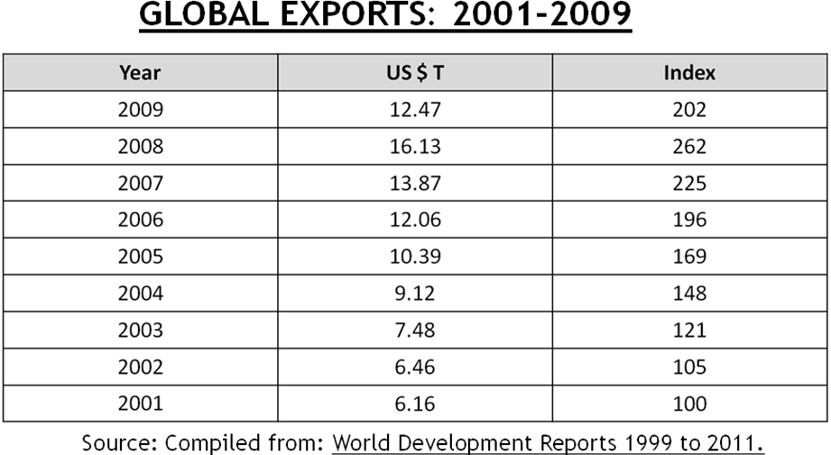
Table No: 1

Based on above figures, the following conclusions have emerged:
1) There was a considerable slow down in global exports in the year 2009 ( $ 12.47 trillion) as compared to year 2008 ( $ 16.13 trillion ).
2) The exports have not risen on consistent basis as is evident in the above data.
3) On account of significant decline in the global exports during 2009, the world has suffered considerably on socio-economic fronts. Consequently, global tensions are growing in several European countries which are caught up in heavy debt crisis. Slogan in USA with an outcry for occupying Wall Street and also occupy Washington DC has been shouted.
The following presents frequency table for global exports for 2009:
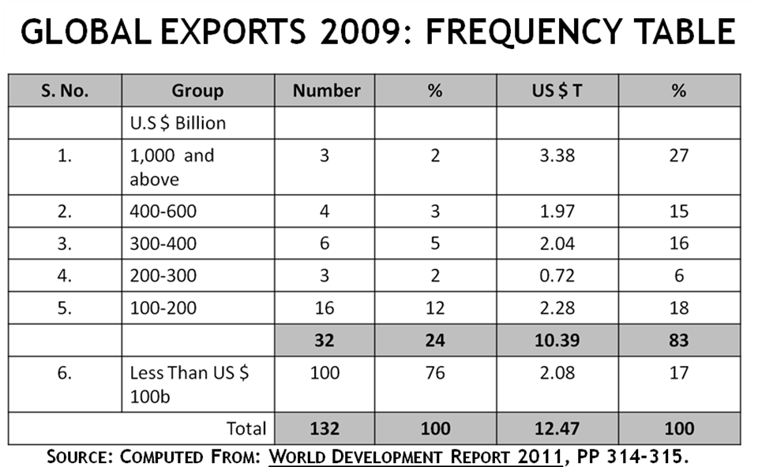
Table No. 2
A study of the above table leads us to the following conclusions:
1) Pareto Law is very much applicable to global exports. 24% countries have bagged 83% exports in value term. This shows high concentration of exports in few countries on global basis.
2) The share of 78 countries is 76%, having less than $ 100 billion exports and they have exported 17% of the global exports. In a positive spirit this should be taken as an agenda of tomorrow so that economic strategies and policies are so structured as to boost export efforts to tap fast potential which lies in the world.
3) China has emerged as export leader No. 1 in the world. It is believed that in the year 1979 their total exports were $ 30 billion and they have now achieved great heights in exports ($ 1.20 trillion). There is a great lesson to learn from the Chinese Export Strategies with varying pricing policies and strong logistics (in-bound and out-bound).
4) Only 12 countries have bagged more than $ 200 billion exports.
5) The above Table is an eye opener and instructive for developing countries to learn lesson. UNITC Geneva may also undertake positive steps to help and encourage developing countries to boost their exports in the light of successful experiences of several countries which have registered considerable increase in exports.
Twelve (12) Top Leaders
Table No. 3 presents Top Twelve (12) Export Leaders on global basis.
Table No: 3
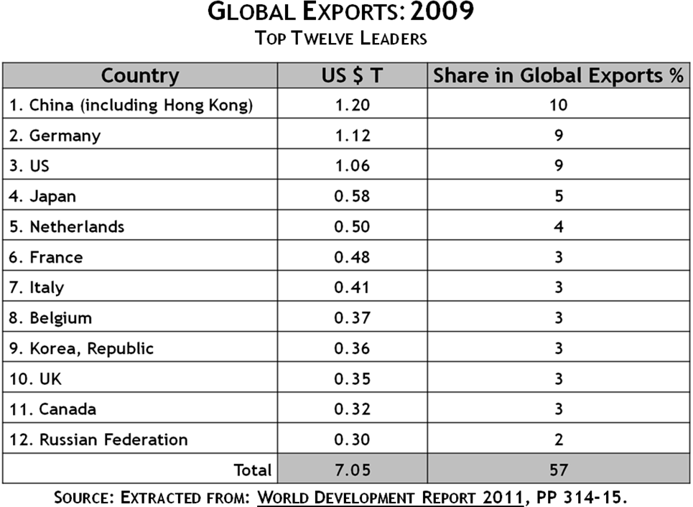

The following conclusions emerge from the above table:
1) The twelve (12) global export leaders have bagged 57% shares in global exports with a total of $ 7.05 trillion.

2) The first three leaders in exports constitute 28% of the global exports namely; China (10%), Germany ( 9 % ) and US ( 9 % ).

3) Republic of Korea has shown an impressive export performance ( $ 0.36 trillion ). It has even surpassed UK, Canada and Russian Federation.
Part – II
A Review of Regional Export Trends
There are several regional alliances in the world. Although free economy has been advertised and verbally championed yet the world is governed by alliances on regional footings. For this research study, we have selected the following regions with focus on their exports performance:
- G8
- NAFTA
- D8
- SAARC
Research study was carried out by analyzing the data available in the World Development Report 2011 in respect of the above regions.
G 8
G8 group was earlier known as G7 as it consisted of seven (7) countries of the world namely; Germany, USA, Japan, France, Italy, UK and Canada. However, subsequently Russian Federation was also included as the 8th member and, therefore, it is known as G8.
The following table presents the export figures relating to year 2009 in respect of the above eight countries alongwith their individual share in percentage relating to global exports.
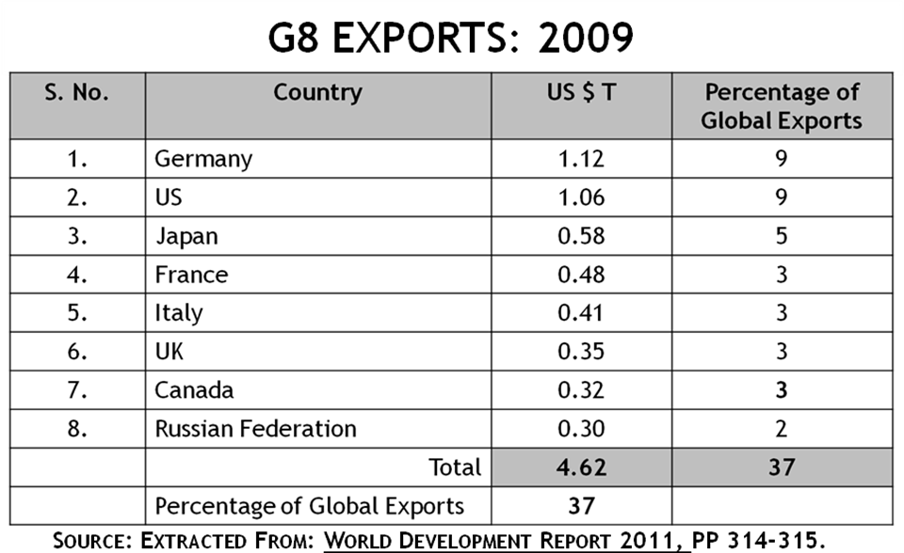
Table No. 4

Analytical study of the above Table reveals the following results:

1) G8 represents 37% of the total global exports.
2) However, their percentage of global exports varies from 9% (Germany and US) to 2% ( Russian Federation ).
3) The global agencies e.g. UN, IMF, World Bank and Regional Development Banks are urged to help develop countries to accelerate their exports so that the concentration of exports in few countries is reduced on wider spread basis across the world. Accordingly, poverty alleviation and socio-economic uplift will take place.
The following Table presents time series data from 2002 to 2009:
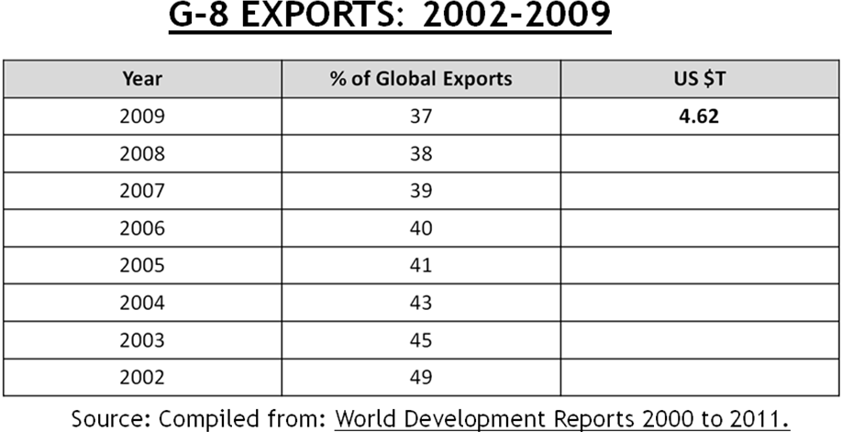
Table No. 5

It shows that as percentage of global exports, the share of G8 is declining, although, in absolute figures in value term may not have declined. In 2002, G8 share in global exports was 49%, whereas, in the year 2009 it declined to 37%. It shows that other countries are also trying to register increase in their exports.
NAFTA
NAFTA stands for Northern American Free Trade Area. It consists of three countries namely, US, Canada and Mexico. This regional alliance of geographically located countries was initiated during the former President of United States (Clinton). The objective was to help encourage in their trade amongst the above three countries. The following Table shows quantitative results:
Table No. 6
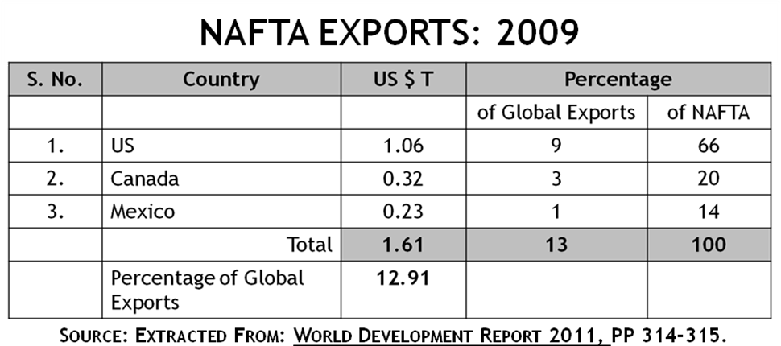
The following conclusions emerge from study of the above table:

1) Share of NAFTA in global exports was 12.91% ( $ 1.61 trillion ).
2) The dominant partner in NAFTA is US ( 66%) followed up by Canada ( 20%) and by Mexico (14% ).
3) The above three countries continue to negotiate with each other for promoting exports amongst themselves.
4) Most of the exports of Canada are to USA. Similar remarks are applicable to Mexico.
The following Table shows time series data relating to NAFTA exports from 2001 – 2009.
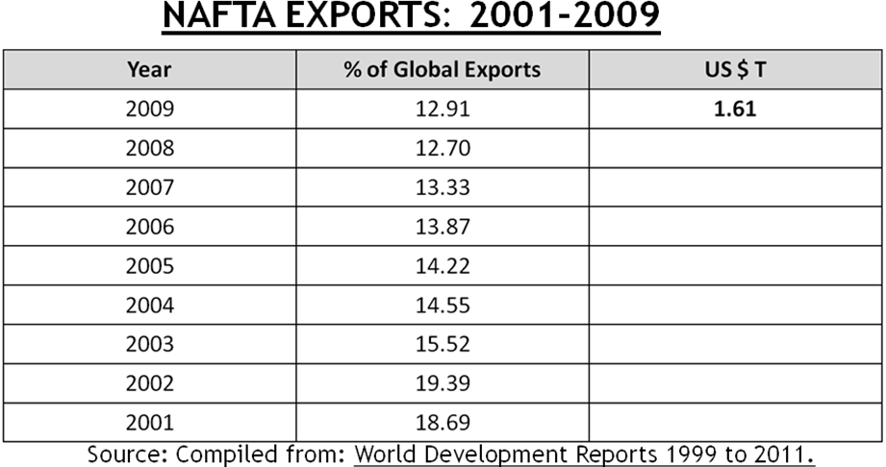
Table No. 7

As a percentage at global exports, NAFTA’s share is declining. It was 18.69% in 2001 and was 12.91 in 2009.
D 8
D8 group was started as developing eight countries. This group consists of some countries from Far-East (Malaysia and Indonesia ), some from SAARC region (Pakistan and Bangladesh), some from Western, Asia (Iran), one country from Europe (Turkey) and two from African continent (Nigeria and Egypt ). Table-8 shows the break up of export performance of above D8 countries.
Table No. 8
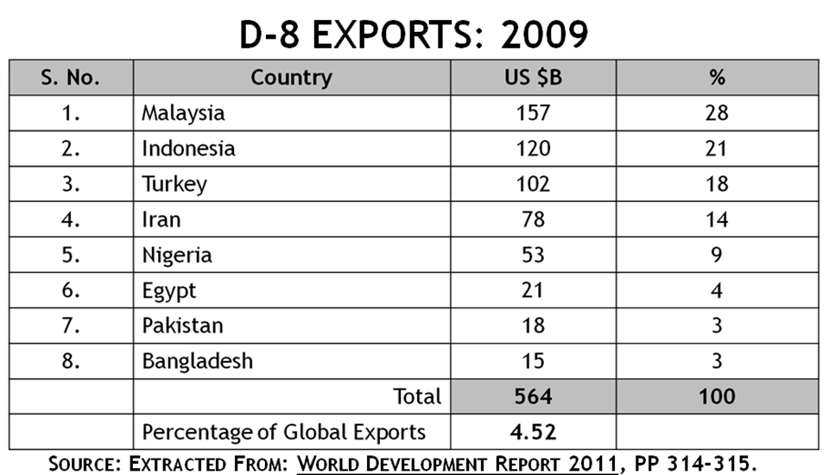
A study of the above Table leads us to the following conclusions:
1) D8 shares in global exports is 4.52%.
- The leading players in D8 constitute 81% (namely; Malaysia: 28%, Indonesia: 21%, Turkey: 18% and Iran: 14% ).
- The variation of the shares within the group is much bigger (e.g. Malaysia: 28% and Bangladesh: 3%).
- Their shares in the global exports is steadily increasing:
SAARC
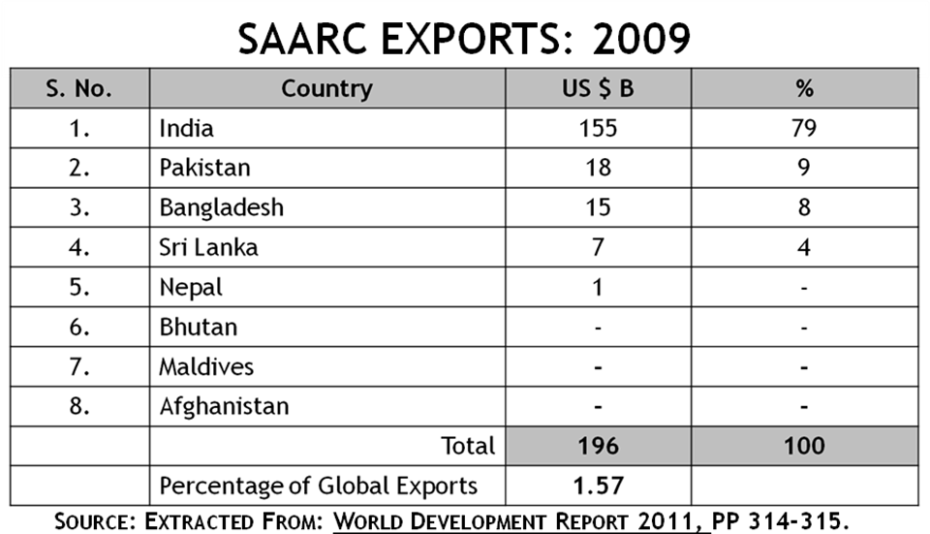
SAARC consists of eight countries of the world namely; India, Pakistan, Bangladesh, Sri Lanka, Nepal, Bhutan, Maldives and Afghanistan. The following Table shows the break up of SAARC Exports in respect of each country:
Table No. 9

The following research conclusions emerge from the above Table:
1) SAARC share in global exports is 1.57%, whereas its total population is 22% in the world. It shows that there is big potential in SAARC which is a sleeping giant. There is a wake up call for it so that its exports may substantially increase and its share in the global exports could also move upward.
2) Three countries namely; Bhutan, Maldives and Afghanistan have even less than $ 1 billion exports.
3) The main exports in SAARC have shown that the emerging sign is India ($ 155 billion) representing 79% of the SAARC exports.
4) The variation within the SAARC countries is very wide – India $ 155 billion and Nepal $ 1 billion.
5) However, there has been steady increase though not very significant, in the time series trends in exports as is shown in the following Table:
Table No. 10

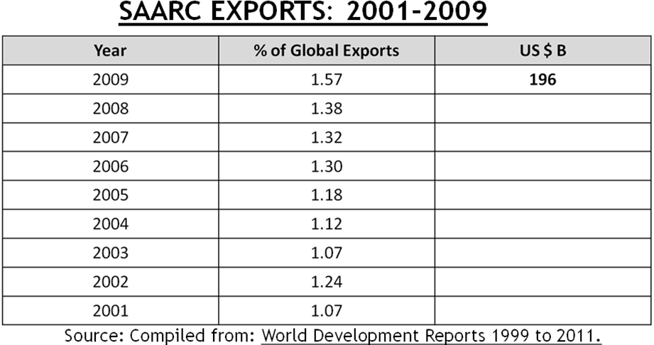

Part – III
Recent Trends of Global Exports: 2010
The World Development Report 2012 is expected to be released in the middle of 2012. This will include figures relating to 2010. However, we have downloaded the relevant available data from Wikipedia giving information under the title of “List of Countries by Exports”. The data released in the above List relate to 225 countries. Incidentally, it may be noted that, as clarified earlier, The World Bank in the World Bank Development Report released data relating to 132 countries of the World. Interesting facts have been revealed which are captured in the following Table:
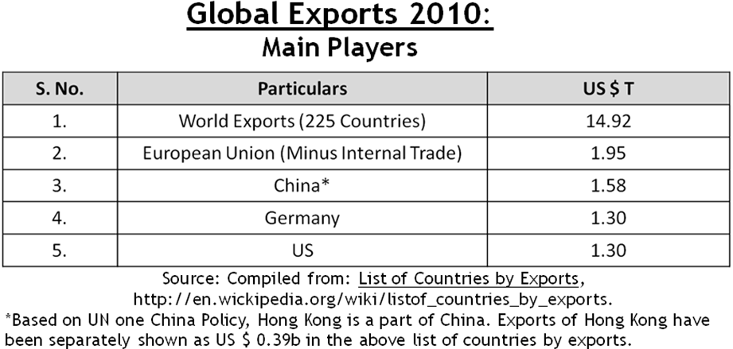
Table No. 11

Global Exports for the above countries are reported with an estimated amount of $ 14.92 trillion which is higher as compared to $ 12.47 trillion relating to 2009 as reported in the World Development Report 2011. It may be noted that the higher amount relating to 2010 is in respect of 225 countries. Excluding external trade, European Union is reported to have exported goods for $ 1.95 trillion. As a regional group this is the highest amount in the world in respect of exports. Peoples Republic of China is reported to have exported $ 1.58 trillion. However, the export of Hong Kong has been separately shown in the above List. There is a foot note clarifying this position in the above Table. On the assumption that if Hong Kong exports have not been included in the above figure relating to Peoples Republic of China and this amount is now included in it, the total exports of Peoples Republic of China will exceed the total exports of European Union. Germany is runner up at position No. 2 with exports of $ 1.30 trillion followed by USA which is reported to have exported goods world $ 1.30 trillion.
From the above downloaded data we have compiled the ranking relating to top twelve (12) global export leaders relating to 2010. The following Table marshals out the ranking:
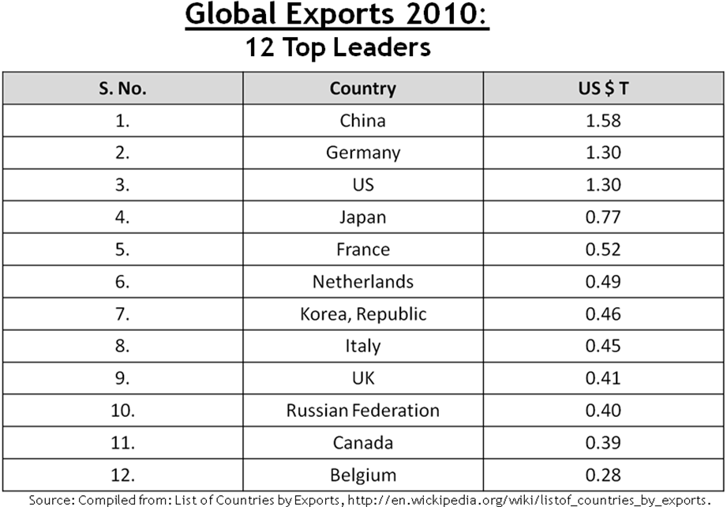
Table No. 12

The first three positions, as usual, have been bagged by three countries namely; China ($ 1.58 trillion), Germany ($ 1.30 trillion) and US ($ 1.30 trillion). The remaining positions have been included in the Table starting with Japan (Rank No. 4: $ 0.77 trillion) and ends up with Belgium ($ 0.28 trillion). It is recommended that developed and developing countries should carefully study export policies of the top ranking 12 export leaders mentioned in the above Table and initiate short-term and long-term measures to achieve quantum jump in their exports which will then generate jobs, alleviate poverty, strengthen social frontiers in terms of stability, substantially achieve increase their GNP and accelerate the socio-economic development in a healthy and growing manner. Eventually, this will reduce the economic and social tensions in which the world as a whole including the West, Asian and African are facing daunting challenges and even in US also there is a call for occupying Wall Street abnd Washington DC and demonstrations around Washington DC alongwith outcry in 90 cities of USA. Even in UK there have been public demonstration calling for cut on War expenditure and not on Welfare.
Conclusions and Recommendations
Based on the foregoing research, the following conclusions emerge:
1) Strategy
Export led strategy can be a useful tool to tackle the growing socio-economic tension on global basis and meet the challenge of job creation.
2) Stakeholders
All stakeholders need to address the slow down of exports in the world so that economic activities can be accelerated to ensure quantum jump in the exports and with its beneficial impact on socio-economic development.
3) Pareto Law
Pareto Law application has been seen in global exports: 83:17. Concentration of exports has been seen in few countries. China has emerged as Leader No. 1 in global exports. Out of 132 countries, 12 countries have exports with over two hundred billion dollar. Even within the 12 top exports leaders of the world, there is a greater heterogeneity with wide variations.
4) G8
G8 share in global exports in 2009 was 37% with Germany as No. 1 and Russian Federation at No. 8 with wide variations.
5) NAFTA
NAFTA share in the global exports in 2009 was 12.91% with wide variation amongst the lowest and the highest exports within NAFTA countries. As percentage on global exports, NAFTA exports are declining.
6) D8
D8 share in the global exports has showed steady increase in the last 10 years. Amongst D8 countries there is a big variation between the highest exports of a member D8 with another member having the lowest exports.
7) SAARC
Despite population of SAARC as 22% of the world, its share in global exports was 1.57% in 2009 with wide variations between the highest (India $ 155 billion) and the lowest (Nepal: $ 1 billion) with four countries having less than $ 1 billion.
8) 2010 Trends
In the estimates for global exports for 2010 containing data for 225 countries exports have shown some increase with China as Leader No. 1 followed up by Germany and US.
Based on above conclusions, there is an urgent need for world as a whole to evolve export led growth as a strategy to boost their production function, creat jobs, accelerate socio-economic development, reduce social tensions and help each other as regional group and the world across the board to develop such export strategies as can enable developing countries in particular and developed countries in general to alleviate poverty, ensure high standard of living and big prosperity and happiness for common man which ought to be the basic goal of new economic strategy to be developed in the 21st century on a breakthrough basis. Commitment is the call of the day and with devotion and sincerity, the above objective can be accomplished.
Selected Bibliography
A: Book
Saeed, Khawaja Amjad, Economy of Pakistan 2011: Oxford University Press, Karachi.
B: World Bank Publications
- World Development Reports 1999 to 2011.
- World Development Indicators 2011.
- World Development Report 2011.
C: Wikipedia
List of Countries by Exports:
http://en.wickipedia.org/wiki/list of _countries_by_exports

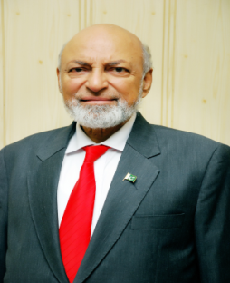
*Professor Emeritus, Founder Principal, Hailey College of Banking & Finance, University of the Punjab, Lahore Pakistan, Member Governing Council, International Federation of Accountants (IFAC) (1997-2000), President, South Asian Federation of Accountants (SAFA) (1997), President, Institute of Cost and Management Accountants of Pakistan (1997-2000), President, Association of Management Development Institutions of South Asia (AMDISA) (1993-96), Pro Vice-Chancellor University of the Punjab, Lahore (1994-1996), Founder Director, Institute of Business Administration (IBA), University of the Punjab, Lahore (1973-1996).

