OUTLOOK EXPRESS
How do I configure Outlook Express for my PU E-Mail Accounts?
The following article explains how to download mail from your hosting account using Outlook Express.
Open Outlook Express.
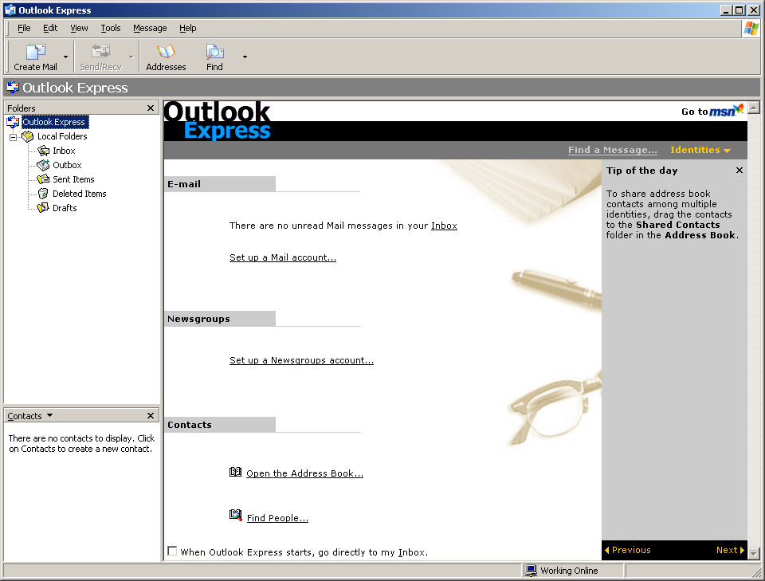

Click on TOOLS and then select ACCOUNTS…
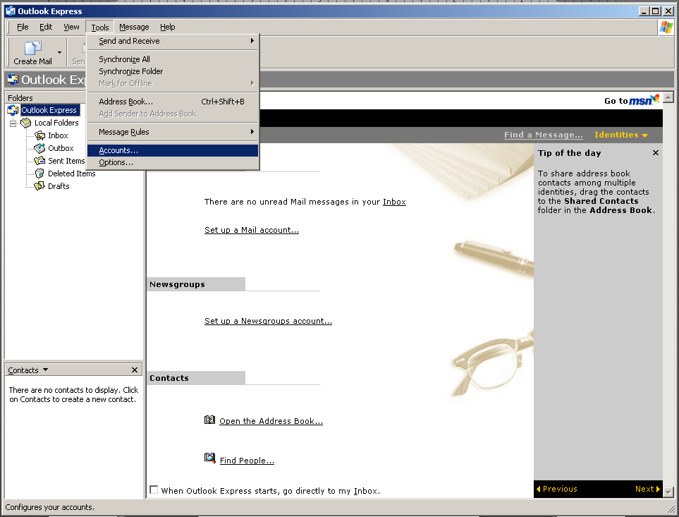

INTERNET ACCOUNT Window will appear
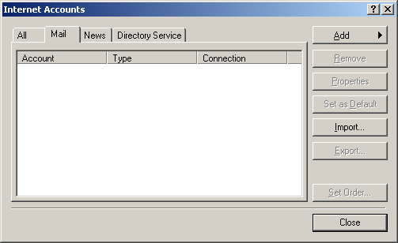

Click on ADD Button and then select MAIL option.
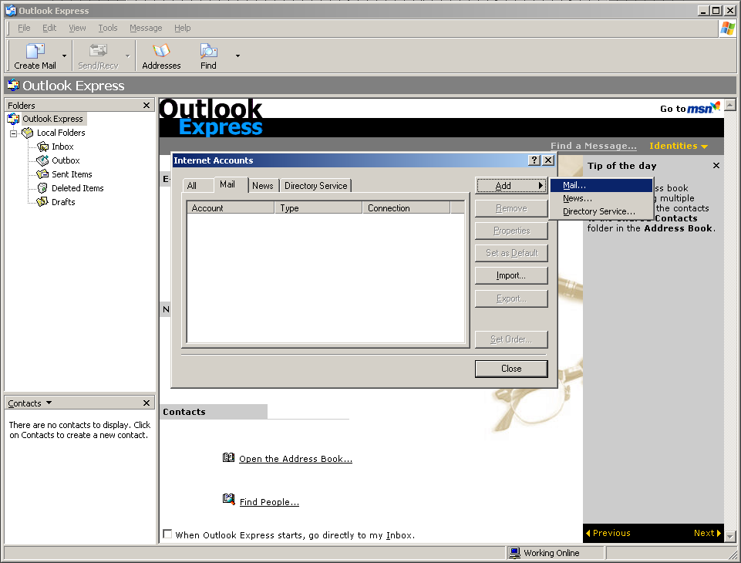

INTERNET CONNECTION Wizard will start.
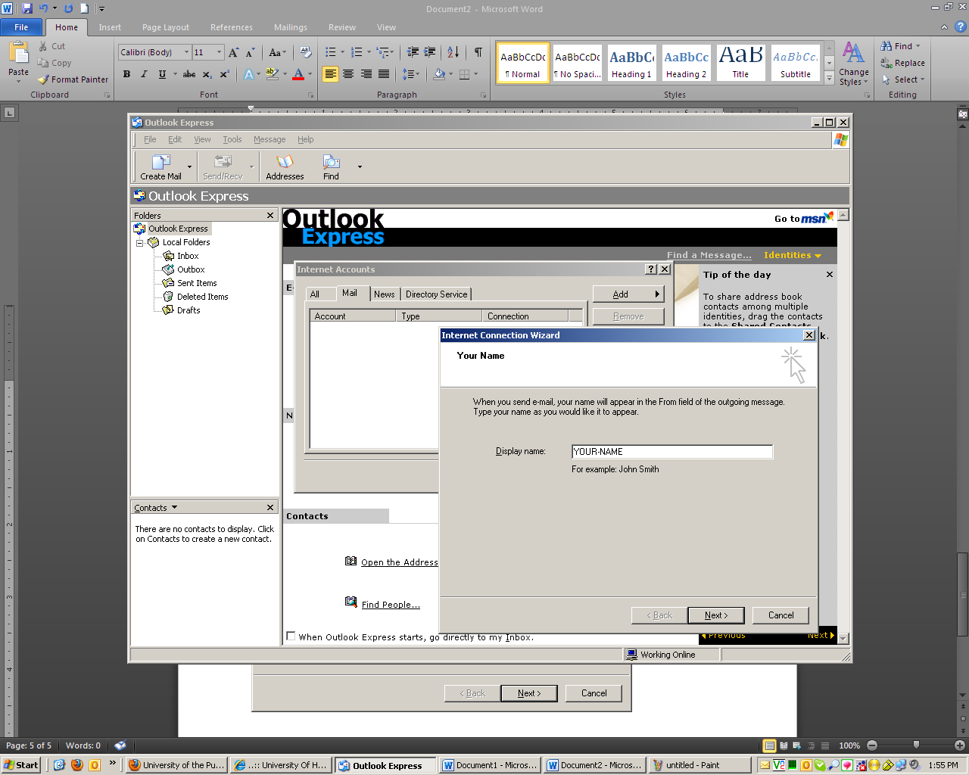

In first step of Internet Connection Wizard window enter your full name in DISPLAY NAME.
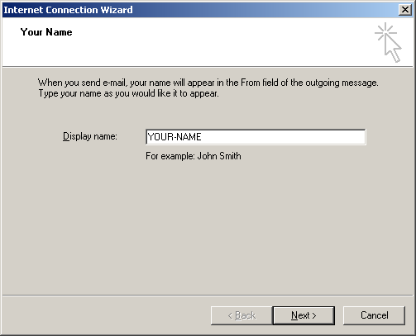

Enter your complete E-MAIL ADDRESS. (With @pu.edu.pk)
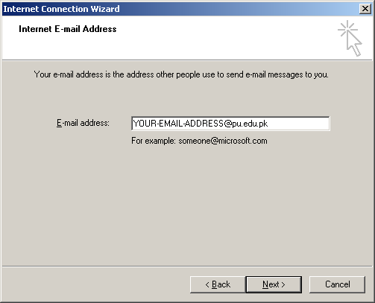

Select POP3 for Incoming Mail Server and enter MAIL.PU.EDU.PK in both INCOMING and OUTGOING MAIL SERVERS.
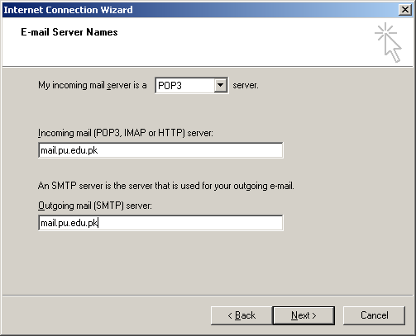
Enter your complete E-Mail Address in ACCOUNT NAME. (With @pu.edu.pk). If required save your password.
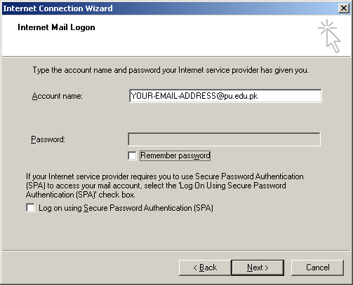
Click on FINISH.
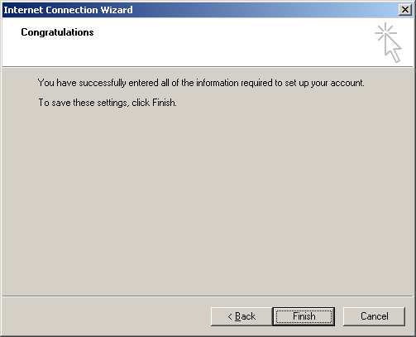

Now an account will be created in Internet Accounts window. Now select the account and click on PROPERTIES button.
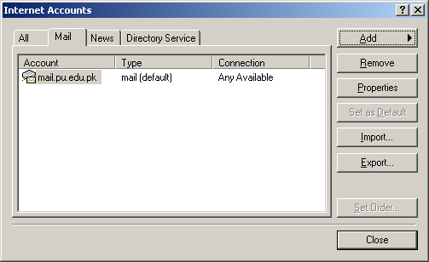

The properties window will open.
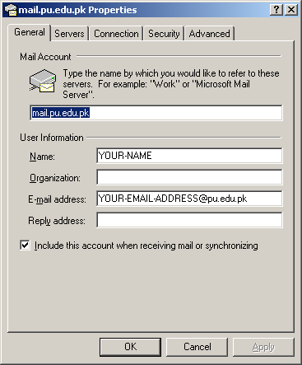
Click on 2nd Tab “SERVERS”, Check on the “My server requires authentication” and then click on Settings button.
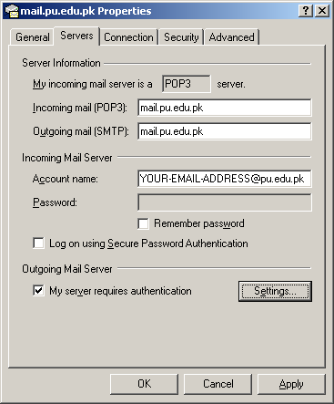
Confirm the option is selected of “Use same settings as my incoming mail server”.
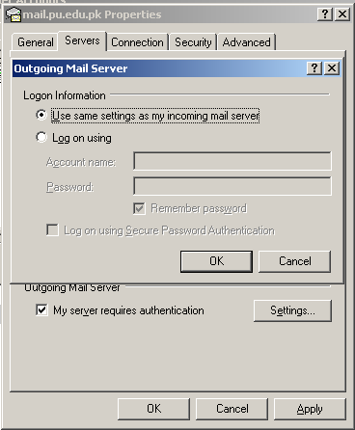
Press OK → again OK.

Click on “Send/ Recv” button to send or receive your Mails in INBOX.
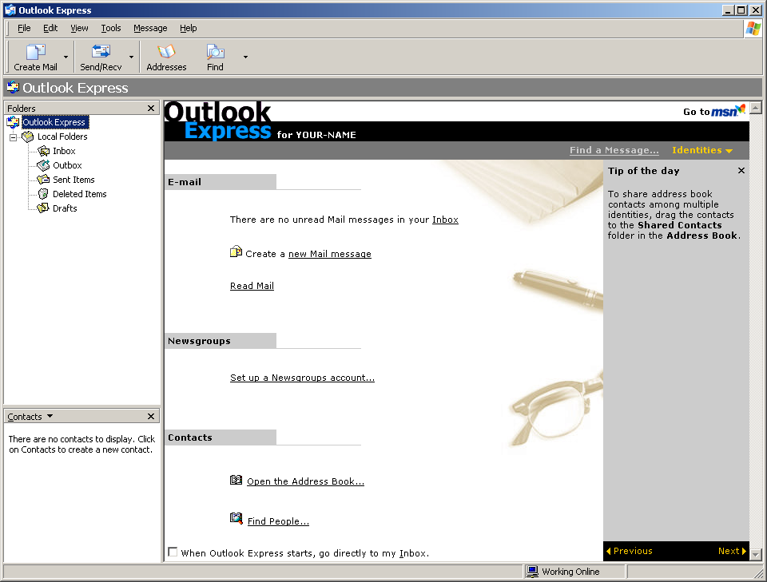
Congratulations, Your E-Mail account has been created on Outlook Express.

In case of any problem and query, please contact Information Technology Centre on following numbers.
+92 42 99230547
+92 42 99231119

