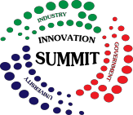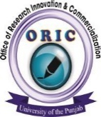**P**

**------------------------------------------------------------------------------------**

**10th Invention to Innovation Summit, 2025**

23 - 24 April 2025

Office of Research Innovation & Commercialization (ORIC)

**University of the Punjab Quaid i Azam Campus, Lahore**

**Registration Form for interactive session**

Please complete and return this form at email **oricsummit2025@pu.edu.pk**

**Last Date for Registration “11 April 2025”**

|  |  |
| --- | --- |
|  |  |

|  |  |
| --- | --- |
| Resource Person/Team Name (s): |  |
| Name of University/Department/  Company/Business/Community etc. |  |
| Area/ Field of Specialization |  |
| Number of Participants |  |
| Postal/Official Address: |  |
| Cell number (Resource Person) |  |
| Email address (Resource Person) |  |
| **Title of the Interactive Session** |  |
| Brief Summary/Details of the Interactive Session: | |

* The resource person/session organizer will invite the participants of relevant field/area. All registered participants will be given certificates.
* Summit organizer will provide session room (Al-Raazi Hall/Seminar Hall ICET) / multimedia / administrative support.

**I/We declare that the information given on this form is true.**

Signature …………………………………………………………………………………………. Date ……………………………………………………..

**FOR OFFICE USE:**

|  |  |  |
| --- | --- | --- |
| **Decision** | * **Accepted** | * **Not Accepted** |

Signature of the Convener of Committee ………………………………………………………