Pakistan Economic and Social Review
Volume 47, No. 1 (Summer 2009), pp. 49-78

GROWTH AND PRODUCTIVITY IN PURVIEW OF
TRANSITIONAL DYNAMICS IN PAKISTAN
AGRICULTURE SECTOR

ABDUL HAMID and HAFIZ KHALIL AHMAD*
Abstract. Agriculture has been the main stay for the economy of Pakistan. It still supports directly or indirectly more than half of the country’s population. This paper aims to analyze the major factors which are responsible for agriculture growth and productivity. Empirical findings show that agriculture productivity is much below its potentials and growth of value-added in this sector still depends on traditional factors of production. Human capital and openness of the economy has a negligible impact on agriculture value-added growth. The study also finds negative impact of technological change and efficiency on employment generation prospects in the agriculture sector of Pakistan.

I. INTRODUCTION
Agriculture has been the mainstay for the economy of Pakistan since its independence (1947). It is still contributing around 20% to GDP and 43% to total employment. Besides providing employment to 43% labour force, 66% of the population of Pakistan living in rural areas, directly or indirectly depends upon agriculture for their livelihood. It also provides raw material to industry and contributes to country’s exports.1 So any policy change for agriculture sector will affect the economy and a large segment of population in the country.
There has been increasing use of modern machinery along with high yielding varieties of seed and fertilizers which, has helped in increasing agriculture value-added growth and overall GDP growth on one hand, and has squeezed the labour absorptive capacity on the other, especially for those who are illiterate or have acquired only general education. This paper aims to determine the major factors of growth and their absolute and relative shares in the agriculture value-added. It also intends to measure total factor pro-ductivity (TFP), the role of technological progress and technical efficiency and their impacts on employment generation prospects in the agriculture.
The layout of the paper is as follows: the review of relevant literature is presented in section II. Section III discusses the methodology, variables and data sources. Discussion of empirical findings and comparisons with some other relevant studies are presented in section IV. Conclusions and policy implications are given in the final section followed by references.

II. REIVEW OF LITERATURE
Robinson (1971) estimated technological change, technical efficiency and spillovers caused by human resource accumulation for 39 developing count-ries and found that, on average, the share of productivity in total growth was 15% in these economies. This is a much smaller percentage attributable to technological change, technical efficiency and human capital accumulation as compared with 50 percent of developed countries.
Yanrui (1995) estimated technical efficiency for the agriculture and manufacturing sectors of China. According to his estimations, technological change and efficiency contributed about 53% in the state industrial sector, 58% in the rural industrial sector, and 55% in the agriculture sector of China.
Bravo-Ureta and Pinheiro (1997) measured technical, economic, and allocative efficiencies in peasant farming for the Dominican Republic using a survey data for the year 1988. Their empirical findings show that average efficiency in the agriculture sector was 70% (efficiency ranging between 42 to 85%).
Fan (1999) analyzed technological change, technical and allocative efficiency in the Chinese agriculture rice sector during the reform period (1980/93). He found that technical efficiency experienced an annual growth rate of 8.5% during 1980/84 and 1.17% during 1985/93. Average technical efficiency growth rate during the reform period was 3.11%. Technological change experienced an average growth rate of 6.98% during the reference period. Modernization of agriculture sector, agriculture research and development, use of pesticides, high yielding varieties of seed, fertilizers and modern technology were the major reasons for this significant technological and technical efficiency growth rate.
Mathijs and Vranken (2000) estimated technological change and tech-nical efficiency for Bulgaria and Hungary using the age of farmers as a proxy for farming experience and got a positive relationship between experience and technical efficiency. In their analysis, they used women education as a determinant for total factor productivity and technical efficiency in the agriculture and found a positive impact of education on productivity.
Rattso and Stokke (2003) analyzed the relationship between productivity, growth and foreign spillovers for the agriculture and industrial sectors of Thailand. Their analysis found a long run relationship between productivity growth and foreign spillovers in both agriculture and industry.
Mundlak (2005) studied pattern of economic and productivity growth in American agriculture for the last two centuries. The average growth rate in US agriculture was 1.0% for the period 1800/1940 and 1.94% for the period 1940/90. Growth rate of productivity with respect to land was zero until 1940. Since then it rose to 2.38%. Labour productivity showed an increase from 0.2% in 1900/40 to 4.08% in 1940/90. The change in labour-land ratio declined from zero in 1800/40 to –1.7% in 1940/90 due to development of modern technology and increase in labour efficiency. As new technology and innovations were largely labour saving, this resulted in out migration to other non-agricultural occupations. This off-migration alleviated rural poverty and underemployment from the agriculture sector and provided cheap labour force to other sectors of the economy.
Swinnena and Vrankena (2006) used a unique set of farm survey data from five European transitional economies (Albania, Bulgaria, Czech Republic, Hungary and Slovakia) to measure technological change, technical efficiency and productivity for the period 1997/2001. They found a significant impact of reforms on TFP, technical efficiency and technological change in the agriculture sector of these economies.
Wizarat (1981) and Burney (1986) estimated technological change, technical efficiency, TFP growth and the spillovers from human capital and found that it contributed significantly to Pakistan’s GDP.
Ali and Hamid (1996) measured technological change, technical efficiency, productivity and their impact on input demand for the agriculture and manufacturing sectors of Pakistan. According to their findings major contributors to the value-added growth in agriculture and manufacturing were the traditional factors of production with capital contributing over 50 percent in both sectors. Technological change and technical efficiency was found labour-saving and capital-using.
Kemal and Ahmed (1992) and Kemal et al. (2002) analyzed technological change, technical efficiency and TFP for Pakistan. According to their findings, overall labour productivity grew at a rate of 1.48 percent for the period 1992/2001. They also made a comparison with other neighboring countries and found that labour productivity growth in Pakistan was lower as compared to its growth in India, Sri Lanka, Bangladesh, Malaysia, Taiwan, and Korea. TFP growth in the agriculture was 0.37% for the sample period. They also found that human resource development, R&D activities, and development of engineering industries (which were the main sources of technical efficiency and productivity growth) had been given less priority and meager resource allocations in Pakistan.
From the literature review given above, it is clear that less attention is given to technological progress, technical efficiency and development of human capital in the agriculture sector of Pakistan. It is thus imperative to devise rigorous policies based on in-depth research of agriculture sector to foster TFP in this sector.

III. METHODOLOGY
Traditionally, the following production function is used to explain variations in agriculture value-added:
Y = f (A, L, K, IP) (1)
Where
Y = Value-added in the agriculture
L = Labour employed in the agriculture
K = Capital stock in the agriculture
IP = Intermediate inputs in the agriculture
A = Level of technology
If we include human resource development (activities like education, training, R&D, etc) and the impact of openness of the economy on the value-added growth in agriculture, the functional form is adapted as:
Y = f (A, L, K, IP, H, T) (2)
Where
H = Human resources development in the agriculture
T = Trade2
In order to measure the major factors contributing to value-added growth, technological change and technical efficiency (which in-builds overtime due to human capital formation), Cobb-Douglas production function is being applied. Equation (2) in the form of Cobb-Douglas production function with variable technological change can be written as (in departing from the traditional Cobb-Douglas function by incorporating additional factors besides just Labour and Capital):3
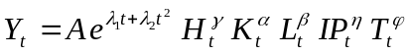 (3)
Where
t = Time trend
λ = Technological Change parameters
A = Constant term
α = Elasticity of value-added with respect to capital
β = Elasticity of value-added with respect to labour
γ = Elasticity of value-added with respect to human capital
η = Elasticity of value-added with respect to intermediate inputs
ψ = Elasticity of value-added with respect to openness of the economy
In view of the possible multicollinearity, between K and L, the following normalized transformed variables are used for estimations.
y_{t} = Y_{t} / L_{t}
k_{t} = K_{t} / L_{t}
h_{t} = H_{t} / L_{t}
tr_{t} = T_{t} / Value-added_{t}
Taking log and using transformed variables, equation (3) in the estimable form can be written as:
ln y_{t} = ln A + λ₁t + λ₂t² + α₁ ln k_{t} + α₂ ln h_{t} + α₃ ln IP_{t} + α₄ ln tr_{t} + u_{t} (4)

MEASUREMENT OF TOTAL FACTOR
PRODUCTIVITY CHANGE INDEX
The total factor productivity (TFP) change index is defined as the difference between rate of change of output and rate of change of inputs:
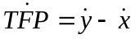 (5)
Where
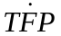 = total factor productivity change index
= rate of change of output
= rate of change of inputs
TFP growth can be estimated by subtracting the contribution of measured inputs growth from output growth.

MEASUREMENT OF ABSOLUTE
AND RELATIVE CONTRIBUTION
The method for calculation of absolute contribution was introduced by Hicks (1979) and calculation of relative contribution by Hadjimichael et al. (1995). The absolute share of any factor of production towards growth can be found by multiplying the estimated coefficient of the explanatory variable by the standard deviation of the respective explanatory variable. The relative contribution for each independent variable can be measured by dividing its estimated absolute share by the standard deviation of the dependent variable. The relative share of variables will be unit free.

Data and Variables Description
Measurement of major factors contributing to value-added growth and productivity, technological change and technical efficiency and their impact on employment generation prospects in the agriculture sector of Pakistan is based on the following variables and data sources (data series cover the period from 1972/73 to 2006/07). All the data are on constant market prices of 1980/81.

Value-added
1. Real Value-added in the agriculture sector on constant market prices
2. Growth rate of real agriculture value-added (percent)
3. Agriculture value-added per employee
4. Growth rate of per employee value-added (percent)

Labour
With following specifications:
1. Number of employed workers in the agriculture and total labour force available
2. Growth rate of Labour Force (percent)

MEASURES OF HUMAN CAPITAL
With following specifications:
1. Expenditure on education and health
2. Expenditure on R&D
3. Number of professionals in agriculture
4. Percentage of skilled, technical and professional workers in the total labour force employed in agriculture
6. Growth of expenditure on education and training (percent)

Capital Stock
Capital stock in the agriculture is measured by using perpetual inventory method as per following equation:
K_{t} = I_{t} + (1 – ϕ) K_{t–1} (6)
Where
K_{t} = Capital Stock in the current year
K_{t–1} = Capital Stock in the previous year
I_{t} = Current Year Investment or Gross Fixed Capital Formation4
ϕ = Depreciation rate
For estimating the initial capital stock K(0), the method used by Nehru and Dhareshwar (1993) and Khan (2006) is being followed. Capital stock series is generated in the following way:
K_{t} = I_{t} + (1 – ϕ)^{t} K₍₀₎ + 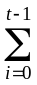 I_{t – i} (1 – ϕ)^{t} (7)
Where
K₍₀₎ = initial capital stock in the base year
Nehru and Dhareshwar (1993) and Khan (2006) used a modified Harberger (1978) method to estimate K₍₀₎. The value of investment for the first year is estimated by way of a linear regression equation of the log of investment against time. The estimated value of investment for the base or zero year is used to calculate K₍₀₎ as per following equation:
K₍₀₎ = I_{t} / (gr + ϕ) (8)
Where
gr = Compound growth rate of value-added in agriculture
ϕ = Depreciation rate
Various depreciation rates have been used in empirical studies. Here, 5 percent capital depreciation rate is assumed as used by Yanrui (2000).5

Intermediate Inputs
Intermediate inputs include fertilizers, high yielding variety of seeds, pesticides, etc.

Trade
Trade and openness of the economy are expected to have a positive impact on value-added growth and productivity in the agriculture. Various definitions like, sum of the agriculture exports and imports, share of agriculture exports and imports to total trade, the sum of foreign direct investment, exports and imports as percentage of GDP are used to measure the impact of openness of the economy on agriculture value-added growth.

Sources of Data
Data sources include the following:
● Pakistan Economic Survey (various issues)
● Labour Force Survey (various issues)
● Agriculture Census (various issues)
● Annual Education Statistics
● Pakistan Statistical Year Book (various issues)
● Federal Bureau of Statistics (1999), 50 Years of Pakistan in Statistics, Volume I-IV. Islamabad: Government of Pakistan.
● Kemal, A. R. (1993), Sources of Growth in Pakistan. Report on Economic and Social Well-being for the Eighth Five Year Plan.
● Human Development Report, UNDP (various issues)
● World Development Report, the World Bank (various issues)

IV. EMPIRICAL FINDINGS
Measurement of major determinants of growth in a closed economy and in an open economy and the calculation of their relative and absolute shares to the value-added growth in the agriculture sector of Pakistan are presented in this section. The measurement of total factor productivity change index (TFPI), labour productivity and its index, agriculture value-added, capital, labour, capital-labour ratio, land-labour ratio, their indices are given in this section. A graphical presentation of these is given. It also discusses the impact of technological changes and technical efficiency on employment generation prospects in the agriculture sector of Pakistan.

MAJOR DETERMINANTS OF GROWTH IN AGRICULTURE

Physical Factors
Estimated results presented in Table 1 show that the traditional factors of production are the main contributors towards value-added growth in the agriculture. Equation (1) in Table 1 shows the estimations for a closed economy. Estimated coefficient for K/L is 0.55 and is significant at 1 percent level of significance, showing that capital per employee in the agriculture is an important determinant of value-added growth. Equation (2) shows the estimations when overall trade to GDP ratio was used as an explanatory variable to measure the impact of the openness of the economy. The estimated coefficient for K/L is 0.87 and is significant at 1 percent level of significance. In equation (3), the sum of agriculture exports and imports is used as an explanatory variable as a proxy for the openness of the economy.
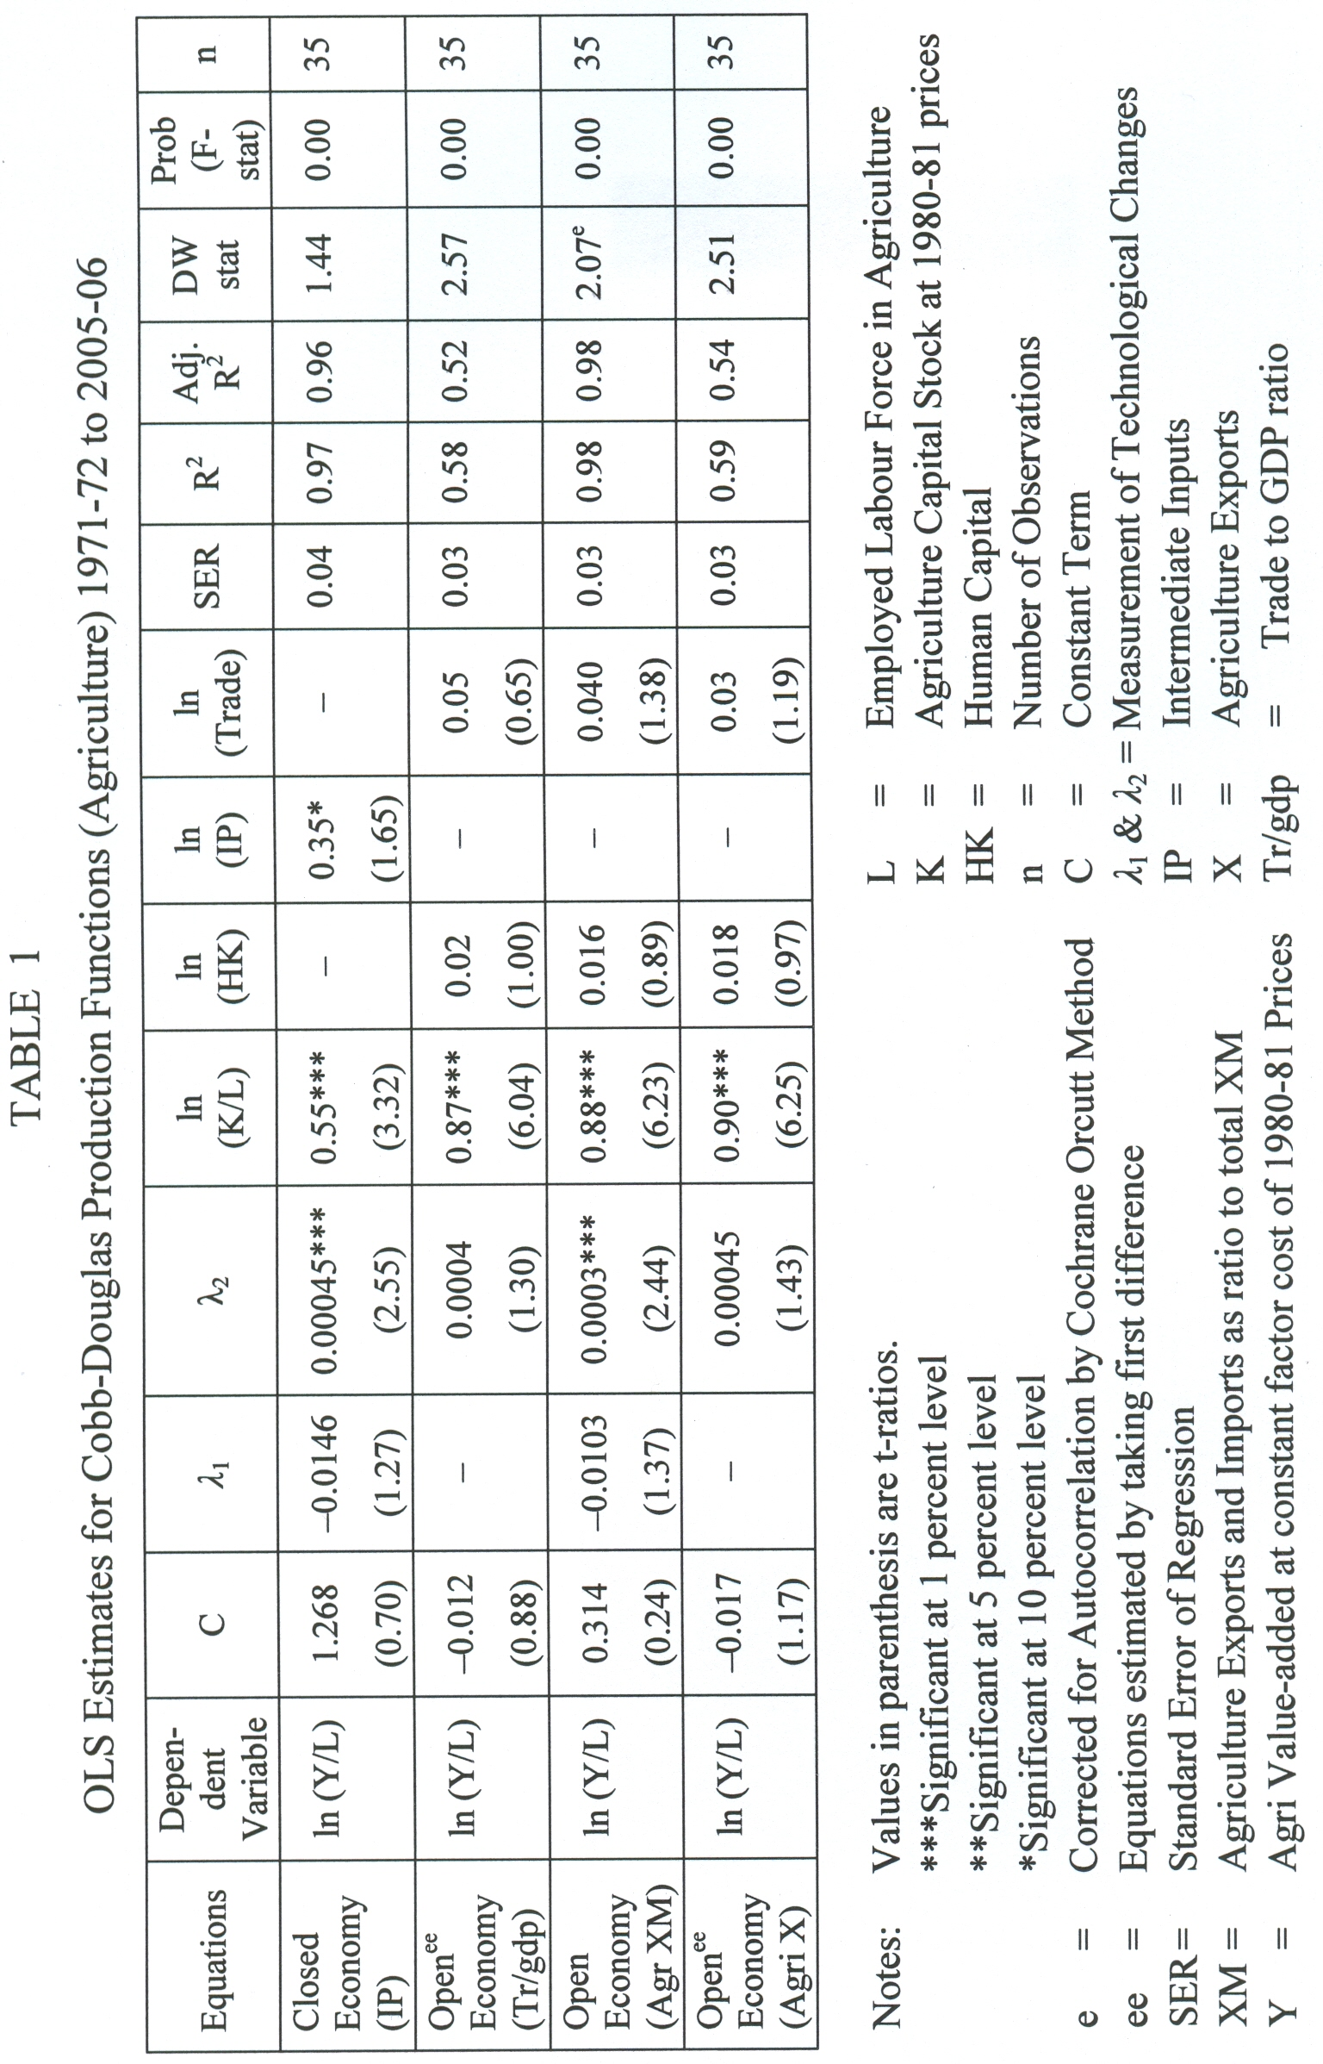
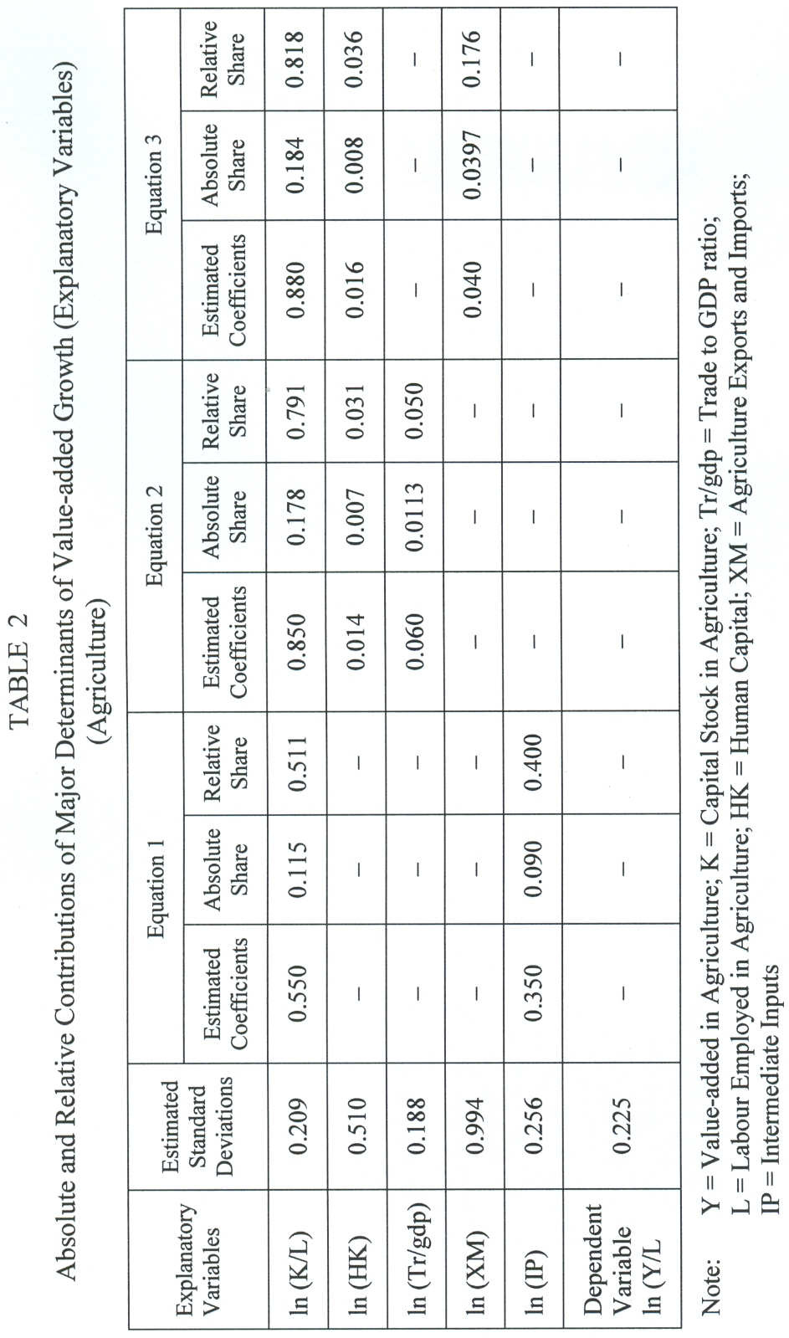
The estimated coefficient for K/L is 0.88 and is significant at 1 percent level of significance. Equation (4) assumed agriculture exports as one of the expla-natory variables. The estimated coefficient for K/L in this equation is 0.90 and is significant at 1 percent level of significance. Estimated coefficients for physical factors in all the equations are positive and statistically significant, indicating that these are the major contributors towards agriculture value-added.

Human Capital
Total enrollment in the agriculture professional colleges, universities and other institutes as a ratio to total employed labour force in the agriculture is used as a proxy to measure the impact of human capital (HK) in the agricul-ture sector.6 Estimated coefficients for HK show positive correlation between human capital and agriculture value-added but are statistically insignificant.

Openness of the Economy
To measure the impact of international trade and openness of the economy on the agriculture value-added growth, three definitions have been used as a proxy for openness, i.e. total trade to GDP ratio (equation 2), the sum of agriculture exports and imports (equation 3) and agriculture exports (equation 4). Estimated coefficients in all three cases show positive impact of trade on value-added growth but are statistically insignificant. Main reasons for this insignificant impact may be that agriculture sector in Pakistan has been working traditionally and yield per acre has been very low. Secondly, Pakistan has given much emphasis on manufactured exports and the share of primary commodity exports has declined form 45 percent in 1971/72 to 11 percent in 2005/06. Thirdly, lack of adequate facilities for packing, storing and conservation of food products and other perishable agriculture items like fruits, vegetables and live stock products, etc., are the major hurdles for accelerated agriculture exports.

Intermediate Inputs
Intermediate inputs like, fertilizers, pesticides, high yielding varieties of seed, etc. play a major role in the growth of agriculture value-added. The impact of intermediate inputs is measured in equation (1) in Table 1. Estimates show that intermediate inputs contribute significantly to the value-added growth in agriculture.

Technology
The estimated results show that continuous technological changes have been taking place in agriculture. All the coefficients are according to theoretical expectations and are statistically significant indicating that technological change and spillovers are positively affecting the growth of value-added in the agriculture.

ABSOLUTE AND RELATIVE CONTRIBUTION OF
MAJOR DETERMINANTS OF VALUE-ADDED GROWTH
The estimated results are depicted in Table 2. In equation (1), the absolute shares for K/L and intermediate inputs are 0.115 and 0.090 respectively. The relative shares for both variables follow the same pattern. The relative share for capital-labour ratio is 0.511 and for intermediate inputs is 0.40. In equation (2), estimated absolute shares for K/L, human capital and trade are 0.178, 0.007 and 0.0113 respectively. The relative shares follow the same sequence, i.e. the maximum share is contributed by K/L, followed by trade and human capital. Estimated results for equation (3) show that the absolute share for K/L is 0.184, followed by agriculture exports and imports (0.0397) and human capital (0.008). Relative shares for K/L, agriculture exports and imports and human capital are 0.818, 0.176 and 0.036 respectively. These results support the estimations presented in Table 1 that agriculture value-added growth depends heavily on physical factors of production and human capital contributes insignificantly.

TOTAL FACTOR PRODUCTIVITY CHANGE INDEX
Table 3 presents the calculations for TFP change index in agriculture. As already mentioned, TFP change is measured as the difference between rate of change of output and the weighted rate of change of inputs. Column (2) shows the rate of change of value-added in agriculture over time, while columns (3), (4) and (5) show weighted rates of change of inputs. The aggregated weighted rate of change of inputs is presented in column (6). The difference between column (2) and column (6), i.e. difference between rate of change of value-added and the rate of change of aggregated weighted inputs is given in column (7) which is the TFP change over time. TFP change for the agriculture sector shows a mix pattern. It experienced a positive growth during 1972/73 to 1981/82. It showed negative growth rates for the next three years, i.e. 1982/83 to 1984/85. TFP in the agriculture experienced positive growth rates during the period 1985-86 to 1999-2000 except for the years 1989/90 and 1991/92. However, since 2000/01 agriculture TFP growth rate has continuously been negative. The reason for
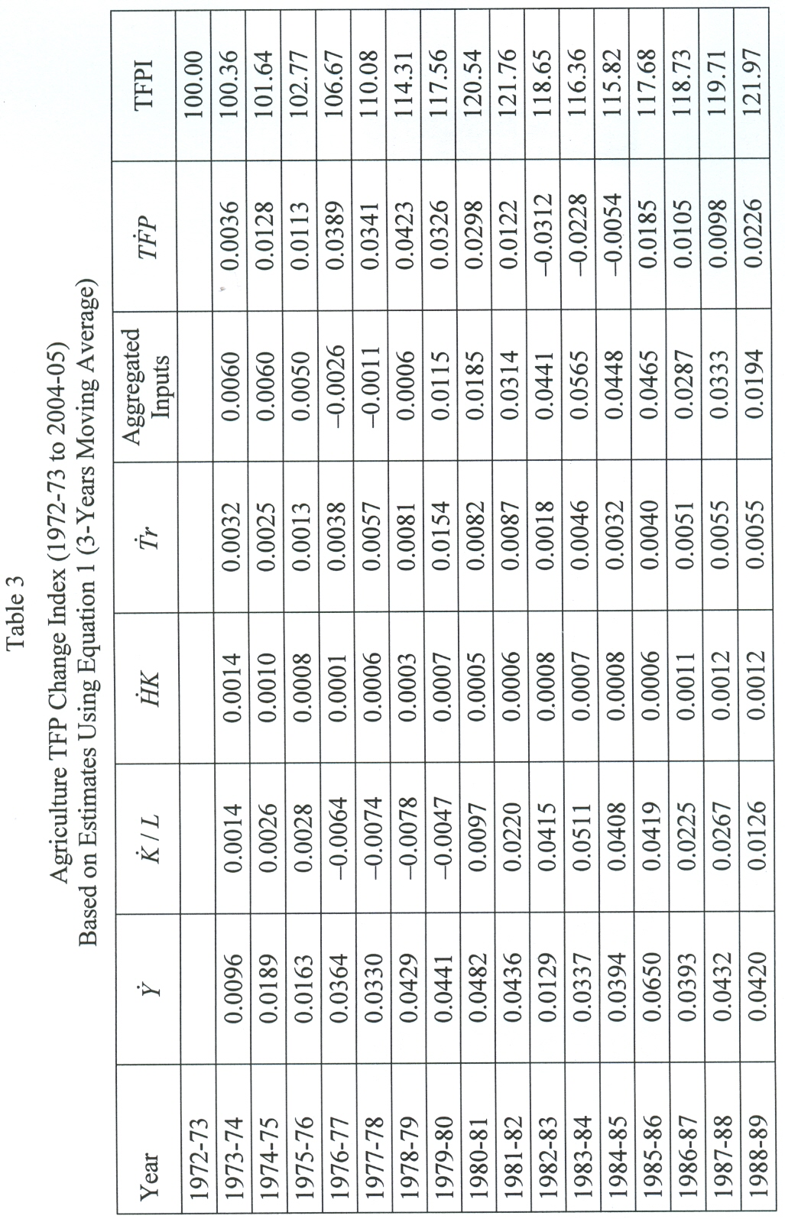
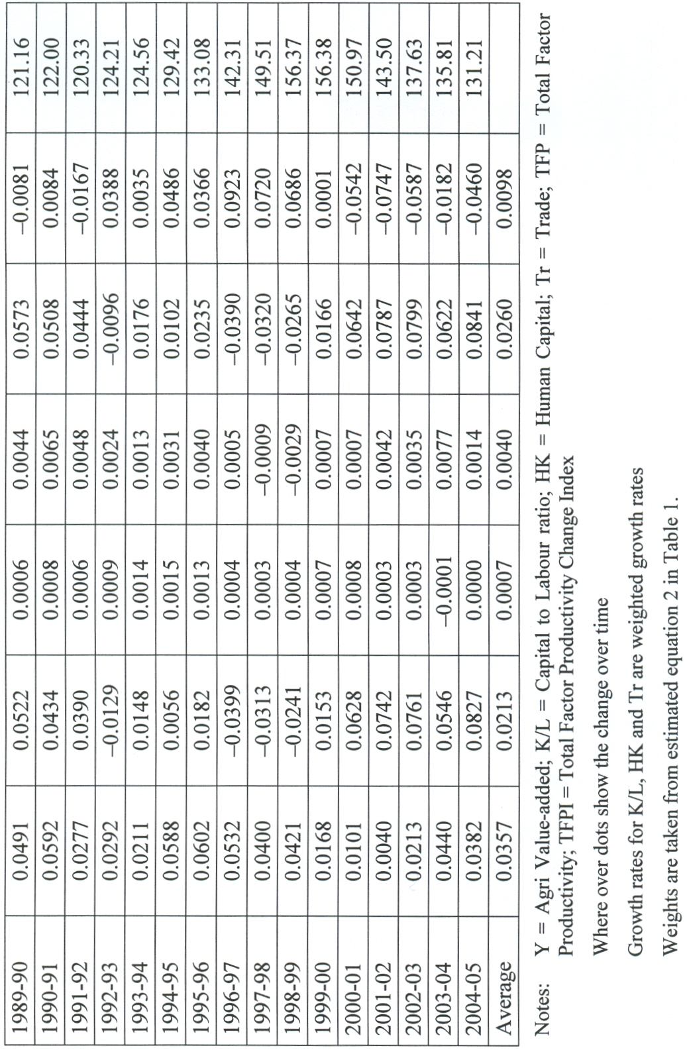
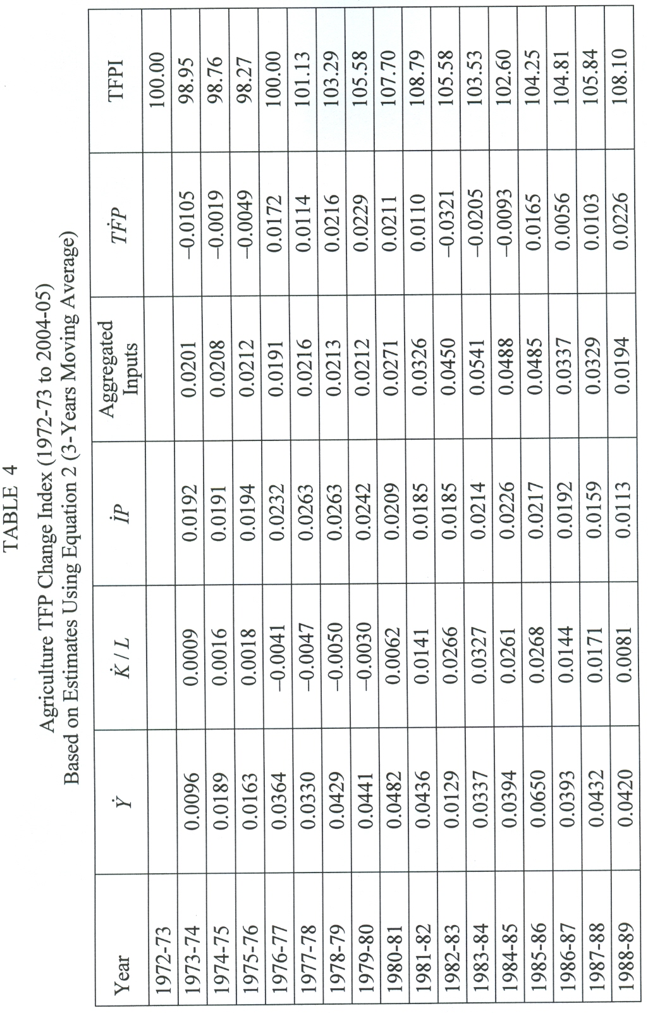
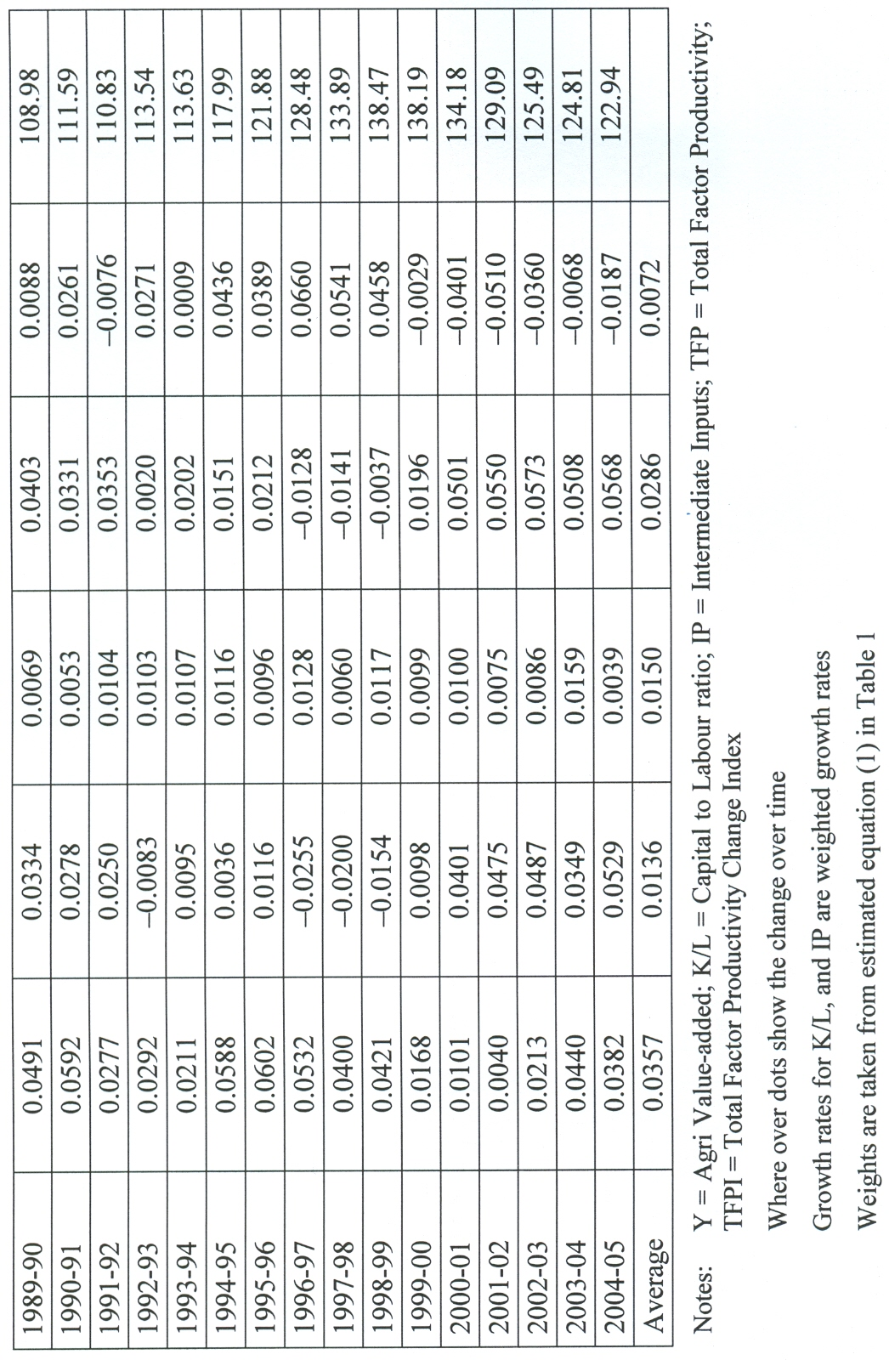
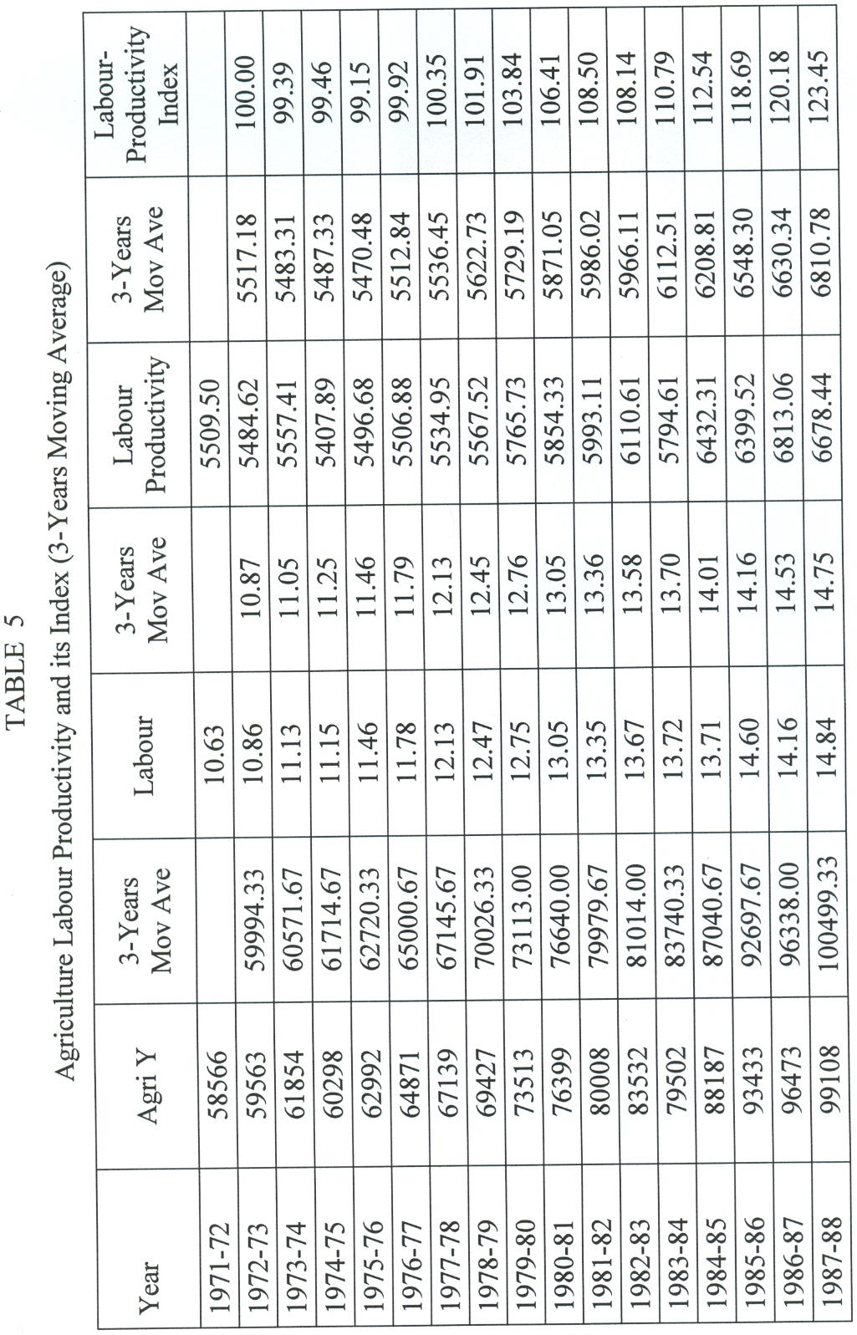
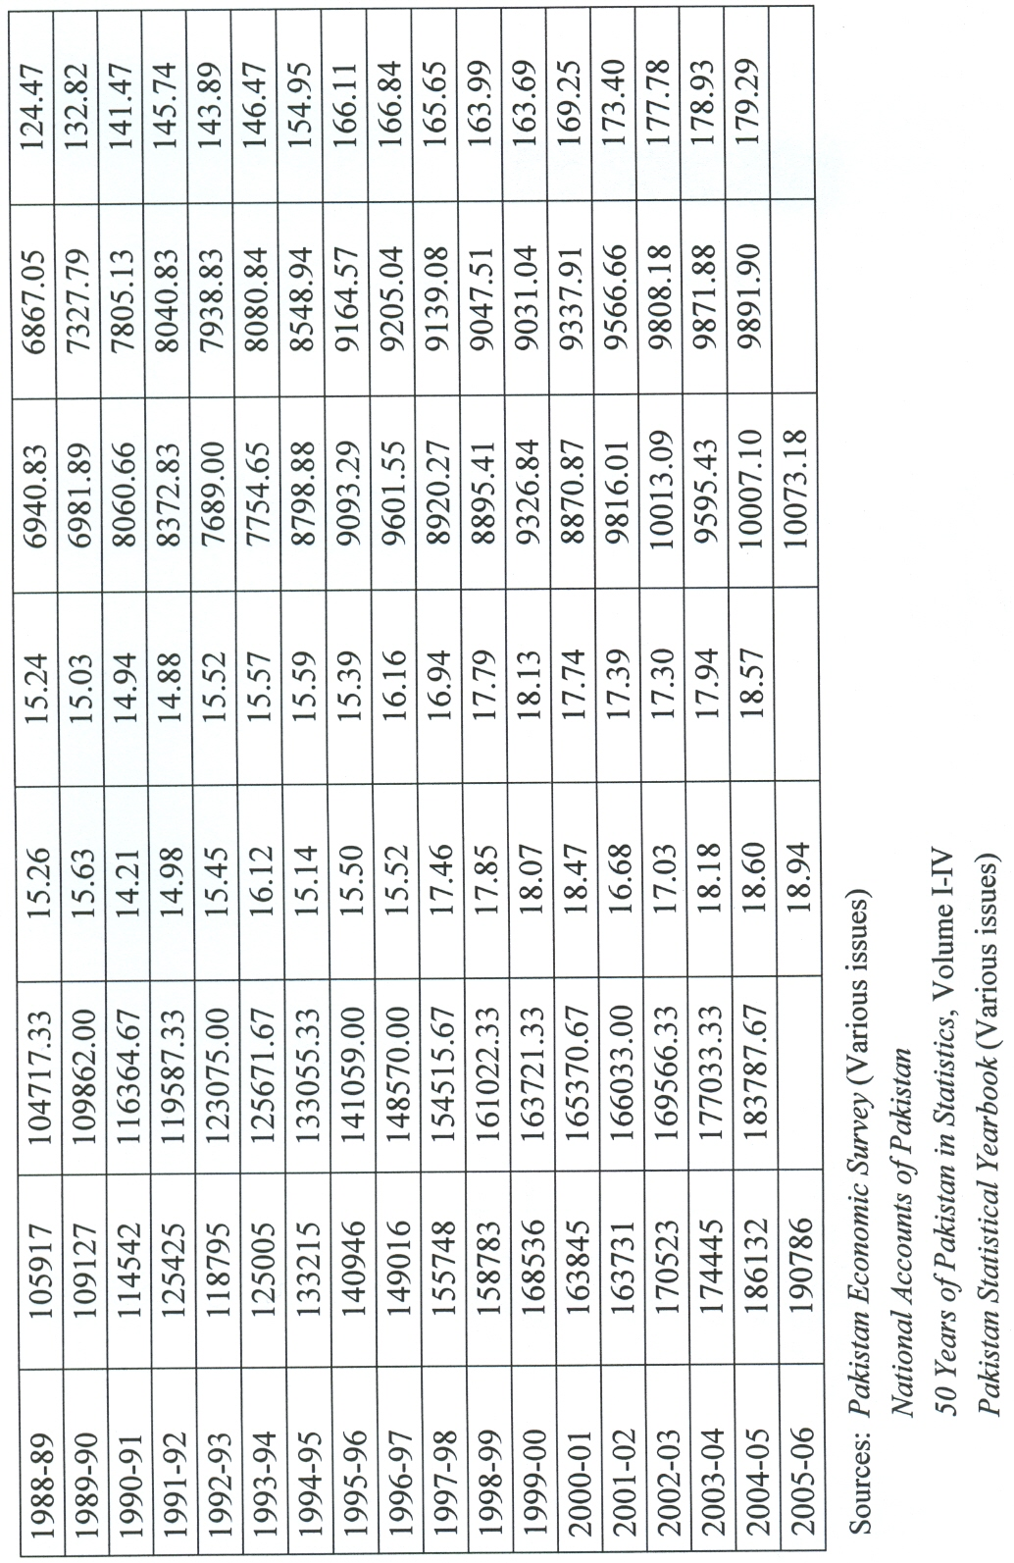
this negative TFP growth rate may be that during last five years of the sample period (except for 2004/05) agriculture growth rate remained either negative or very negilible.7 Three-years moving average growth rates for value-added, aggregated inputs and TFP in the agriculture sector for the sample period are 0.0357, 0.0260 and 0.0098 respectively. The last column in Table 3 is TFP change index which has increased from 100 in 1972/73 to 131.21 in 2005/06. It experienced the maximum value in 1999/2000 which was 156.38. After that it has a declining trend due to negative TFP growth rate during the last five years of the sample period.
An alternative measure of TFP is depicted in Table 4. Weights for its calculations have been used form estimated equation (1) in Table 1. Three-years moving average growth rate for value-added is presented in column (2). Column (3) shows three-years moving weighted growth rate for K/L. Weighted growth rate for intermediate inputs is given in column (4). Column (5) depicts the aggregated weighted inputs growth rates. Change in TFP is the difference between column (2) and column (5), i.e. difference between value-added growth and aggregated weighted inputs growth rate. TFP change shows almost the same pattern as depicted in Table 3.
Graphical presentation for TFP change index, calculated from equation (1) and equation (2), is given in Figures 1 and 2. Both figures show almost the same trends for TFP indices. TFP change index shows an increasing trend but at a slower rate, indicating that technological changes and technical efficiency along with human capital are not playing significant role in the value-added growth.

LABOUR PRODUCTIVITY
Table 5 presents value-added, employed labour force, labour productivity and its index in the agriculture.8 The labour productivity increased from Rs. 5510 in 1971/72 to Rs. 10073 in the year 2005/06.9 Labour productivity index is presented as three-years moving average. It shows a declining trend for the initial five years of the sample period. The major causes for this may be the separation of East Pakistan in 1971, as jute crop in East Pakistan had been one of the major cash crops of Pakistan. Secondly, drastic policy changes for the industrial sector in the form of nationalization during 1970s (as nationalization policy caused significant decline in the industrial growth and performance, and had negative impacts on the economy and on other sectors including agriculture as intermediate inputs and mechanization of agriculture directly depends on industrial sector). The impacts of above mentioned factors can be seen from the annual average growth of agriculture sector during 1970s which was only 2.4 percent while during 1960s it was 5.1 percent and during 1980s it remained 5.4 percent. The overall labour productivity index increased from 100 in 1972/73 to 179.29 in 2004/05. The mechanization of agriculture sector and use of improved intermediate inputs like fertilizers, pesticides and high yielding varieties of seed has led to increase in the labour productivity over the sample period. However, the performance of agriculture sector in Pakistan still lags far behind the perfor-mance and productivity in developed and in many developing countries.

TRENDS OF AGRICULTURE VALUE-ADDED, INPUTS INDICES
AND EMPLOYMENT GENERATION PROSPECTS
Table 6 shows agriculture value-added index, labour index, agriculture capital stock index, capital to labour ratio and K/L index, land-labour ratio and its index.10 The value of agriculture value-added index has increased from 100 in the year 1972/73 to 306.34 in 2004/05 compared with the value of capital index from 100 to 365.88 and that of labour from 100 to 170.87 during the same period. Value of capital-labour ratio increased from Rs. 8894.10 to 19050.82 and its index value increased from 100 to 214.20 for the same period.11 Figure 3 gives the graphical presentation of value-added, capital and labour indices. The Land-labour ratio has declined overtime. The value of land-labour ratio shows a decline form 1.77 in 1972/73 to 1.19 in the year 2004/05. Its index decreased from 100 to 67.52 for the same period.
The values in Table 6 and graphical trends presented in Figures 3 and 4 show that elasticity of labour with respect to value-added is very low. The process of mechanization in the agriculture is labour-saving (as has been explained by capital and labour indices during the reference period). Mundlak (2005) also found that in the US agriculture sector, technological changes and technical efficiency lead to labour saving and out-migration. Though agriculture is still the mainstay for employed labour force in Pakistan, with the mechanization process and technological changes, its
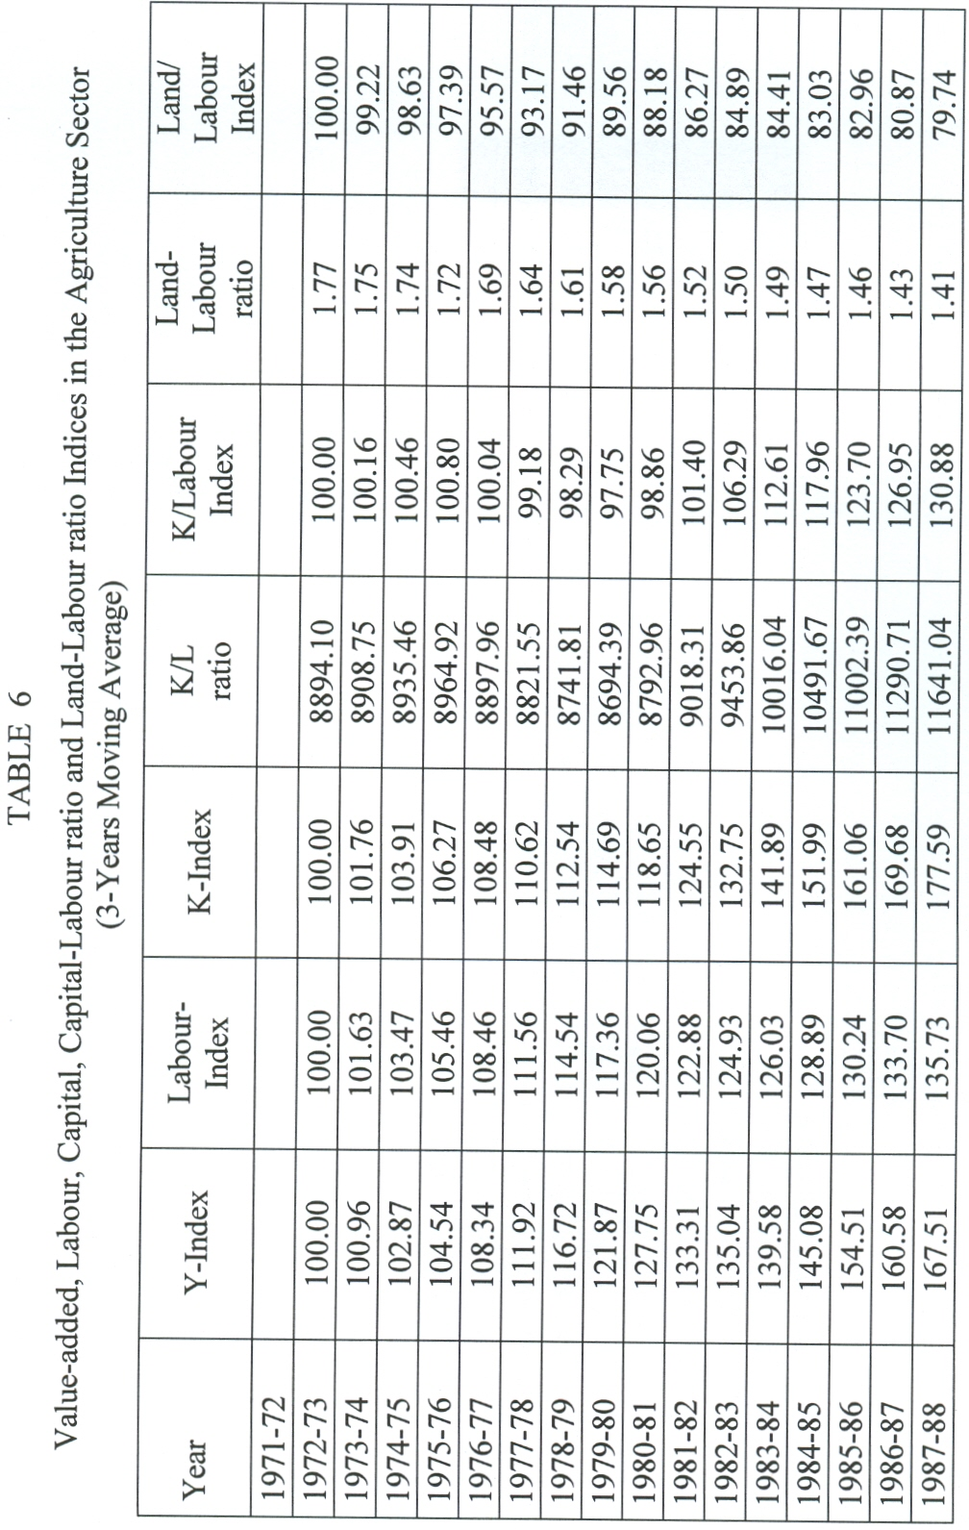
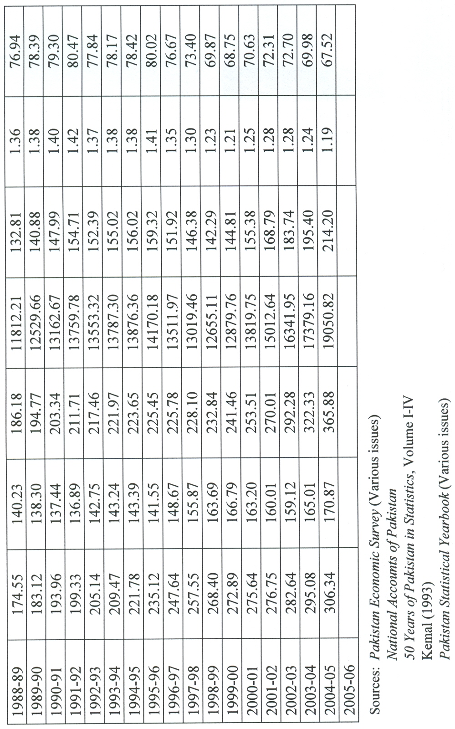
FIGURE 1
Total Factor Productivity in Agriculture Sector (Based on Equation 1)
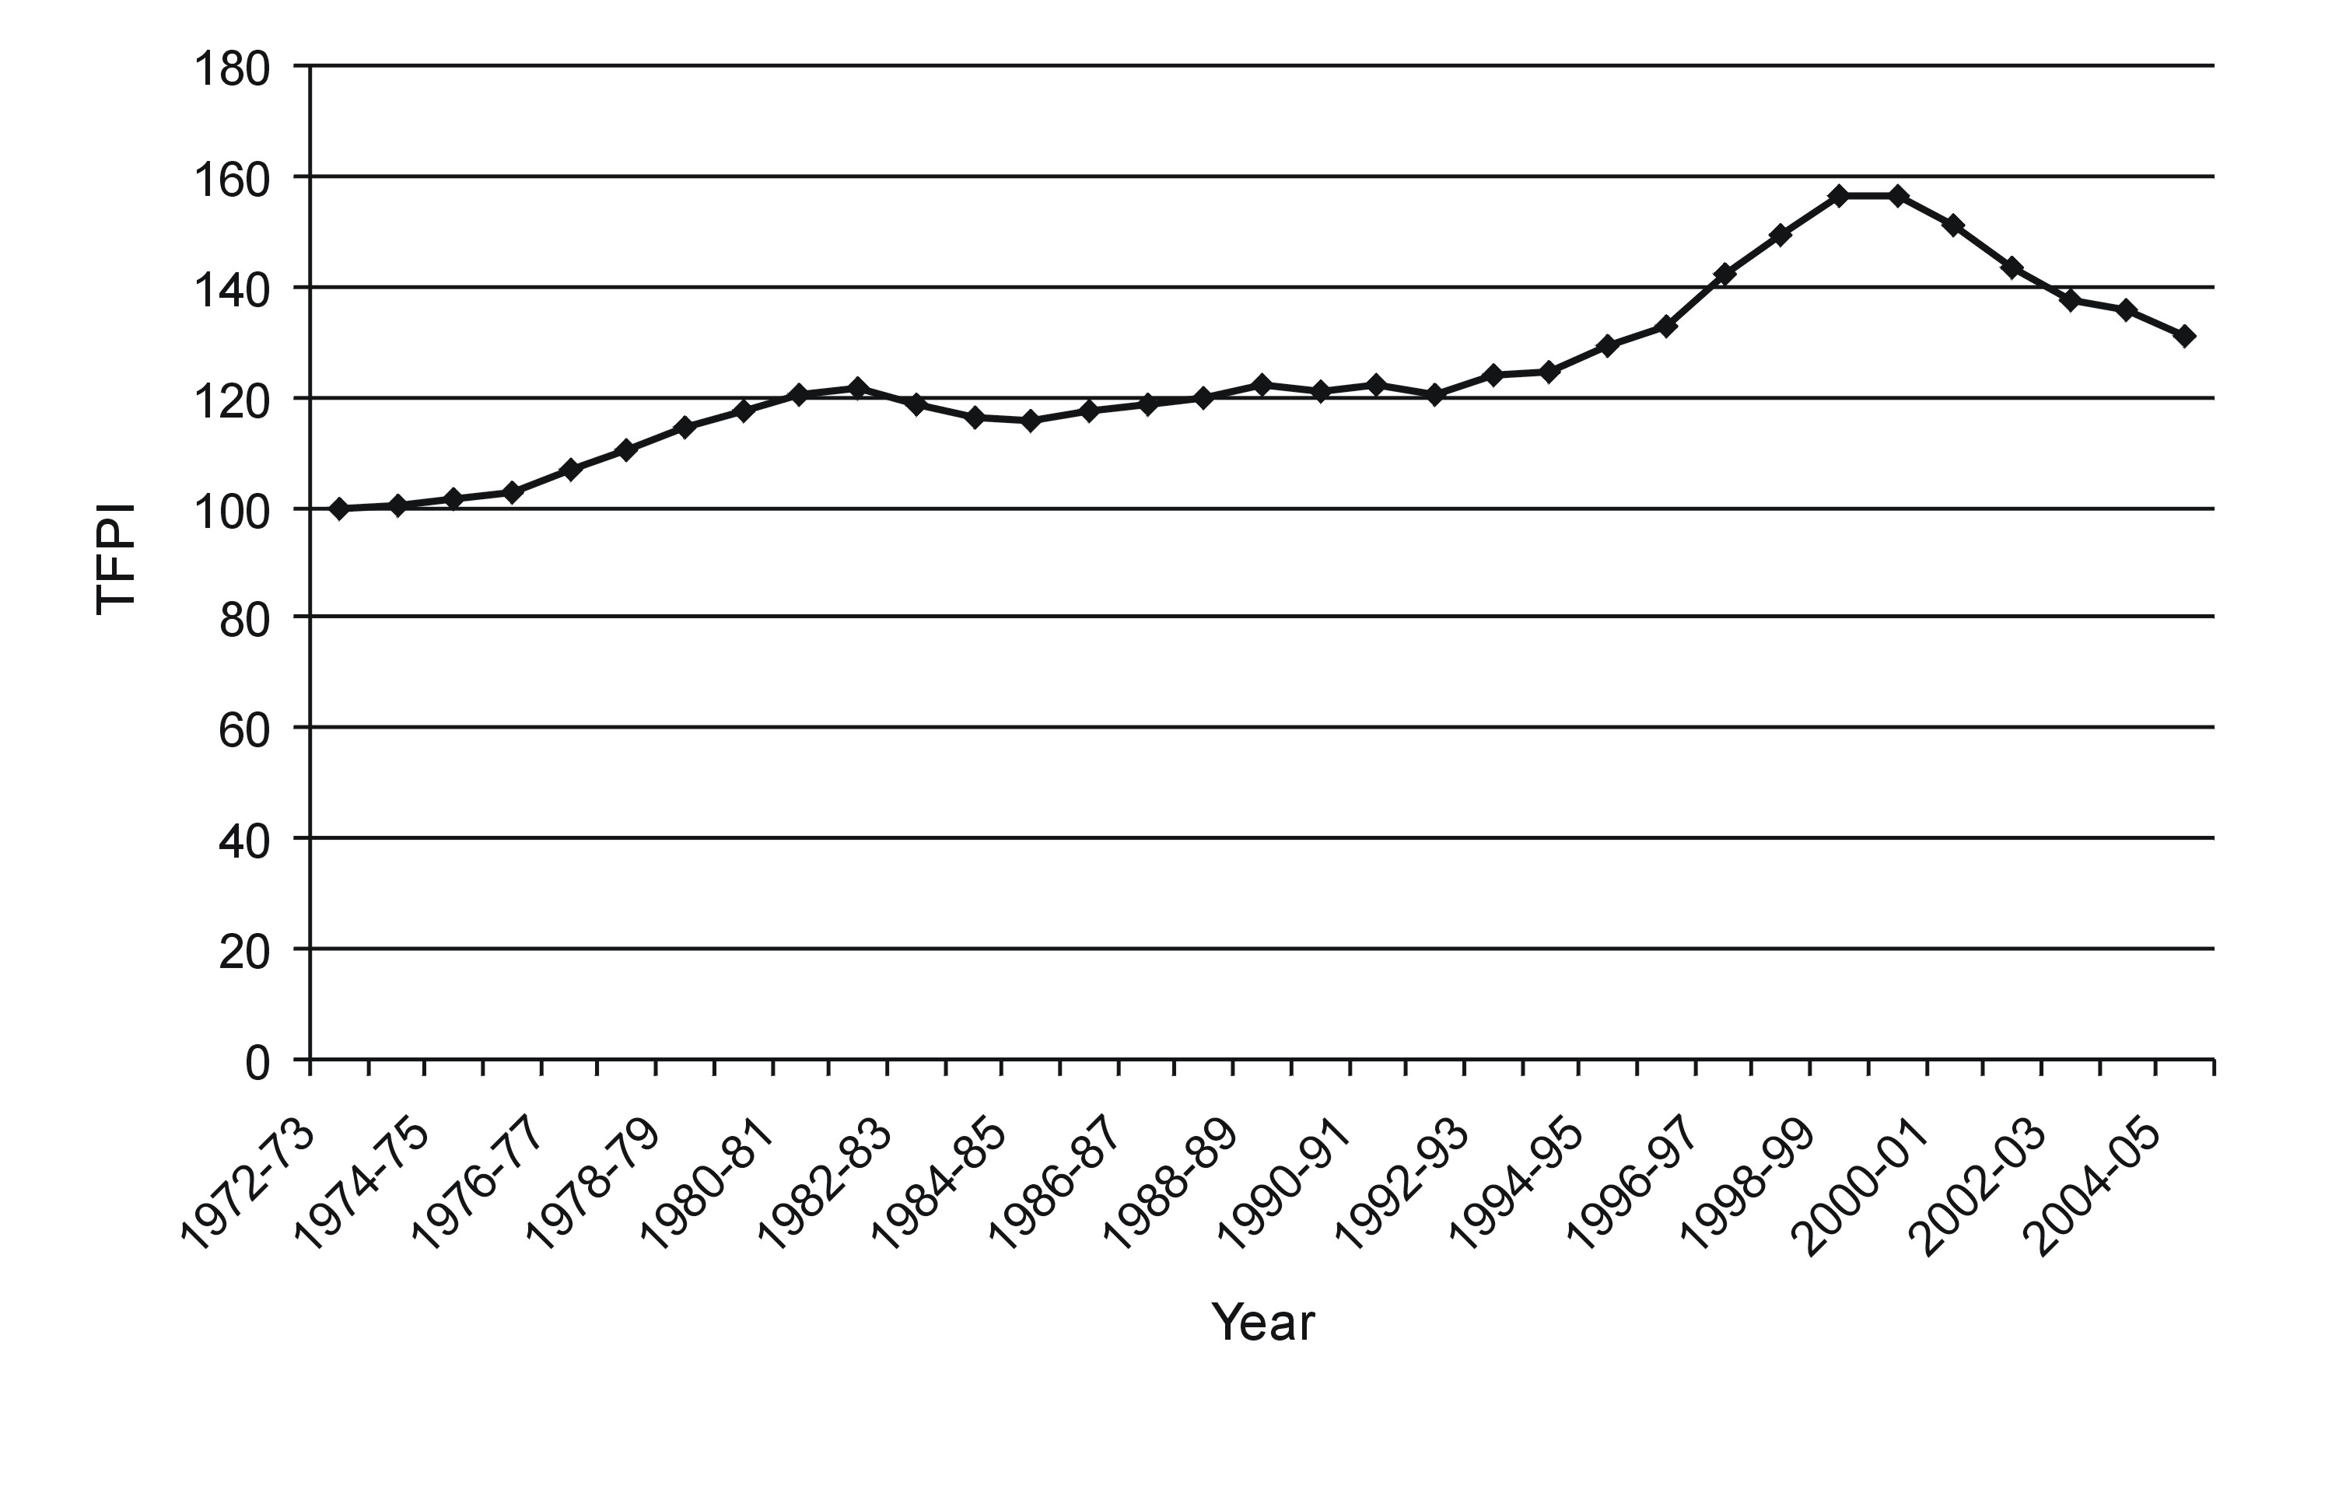
FIGURE 2
Total Factor Productivity in Agriculture Sector (Based on Equation 2)
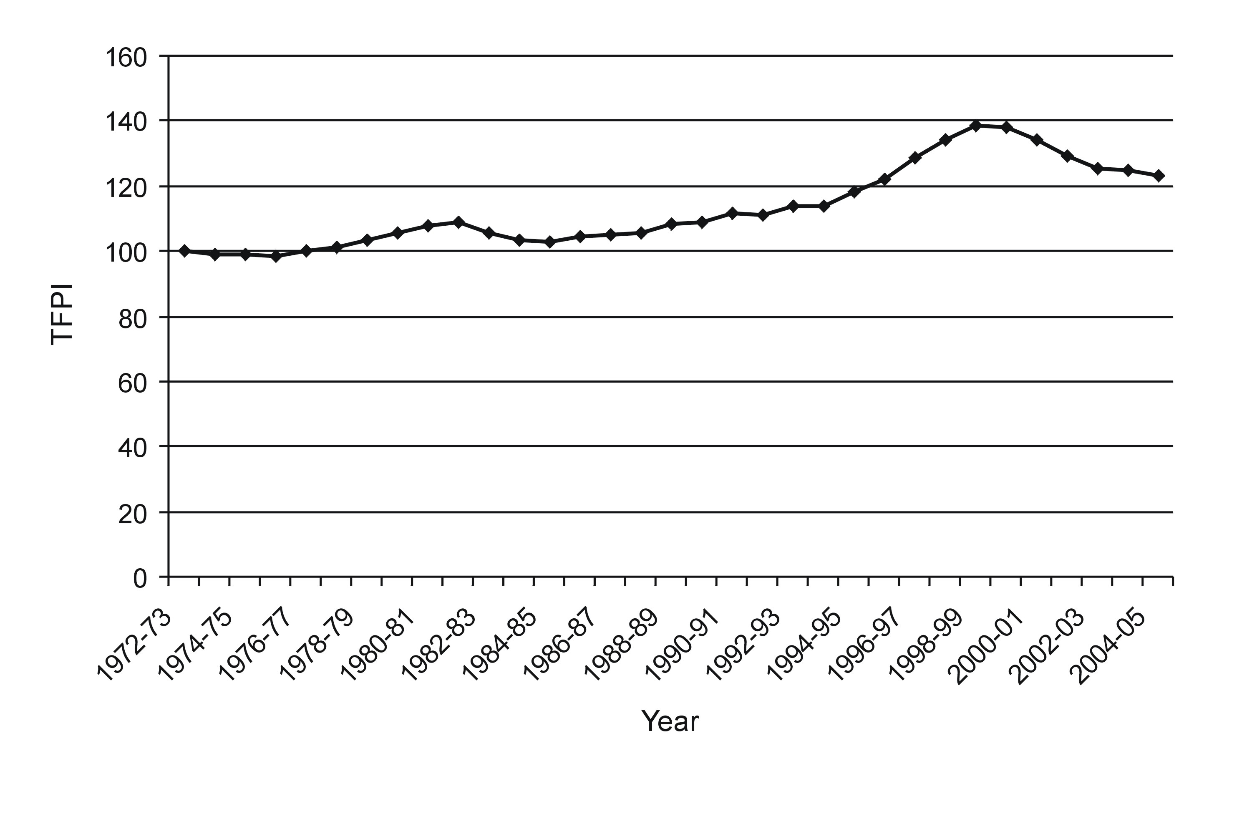
FIGURE 3
Agriculture Value-added, Labour and Capital Indices
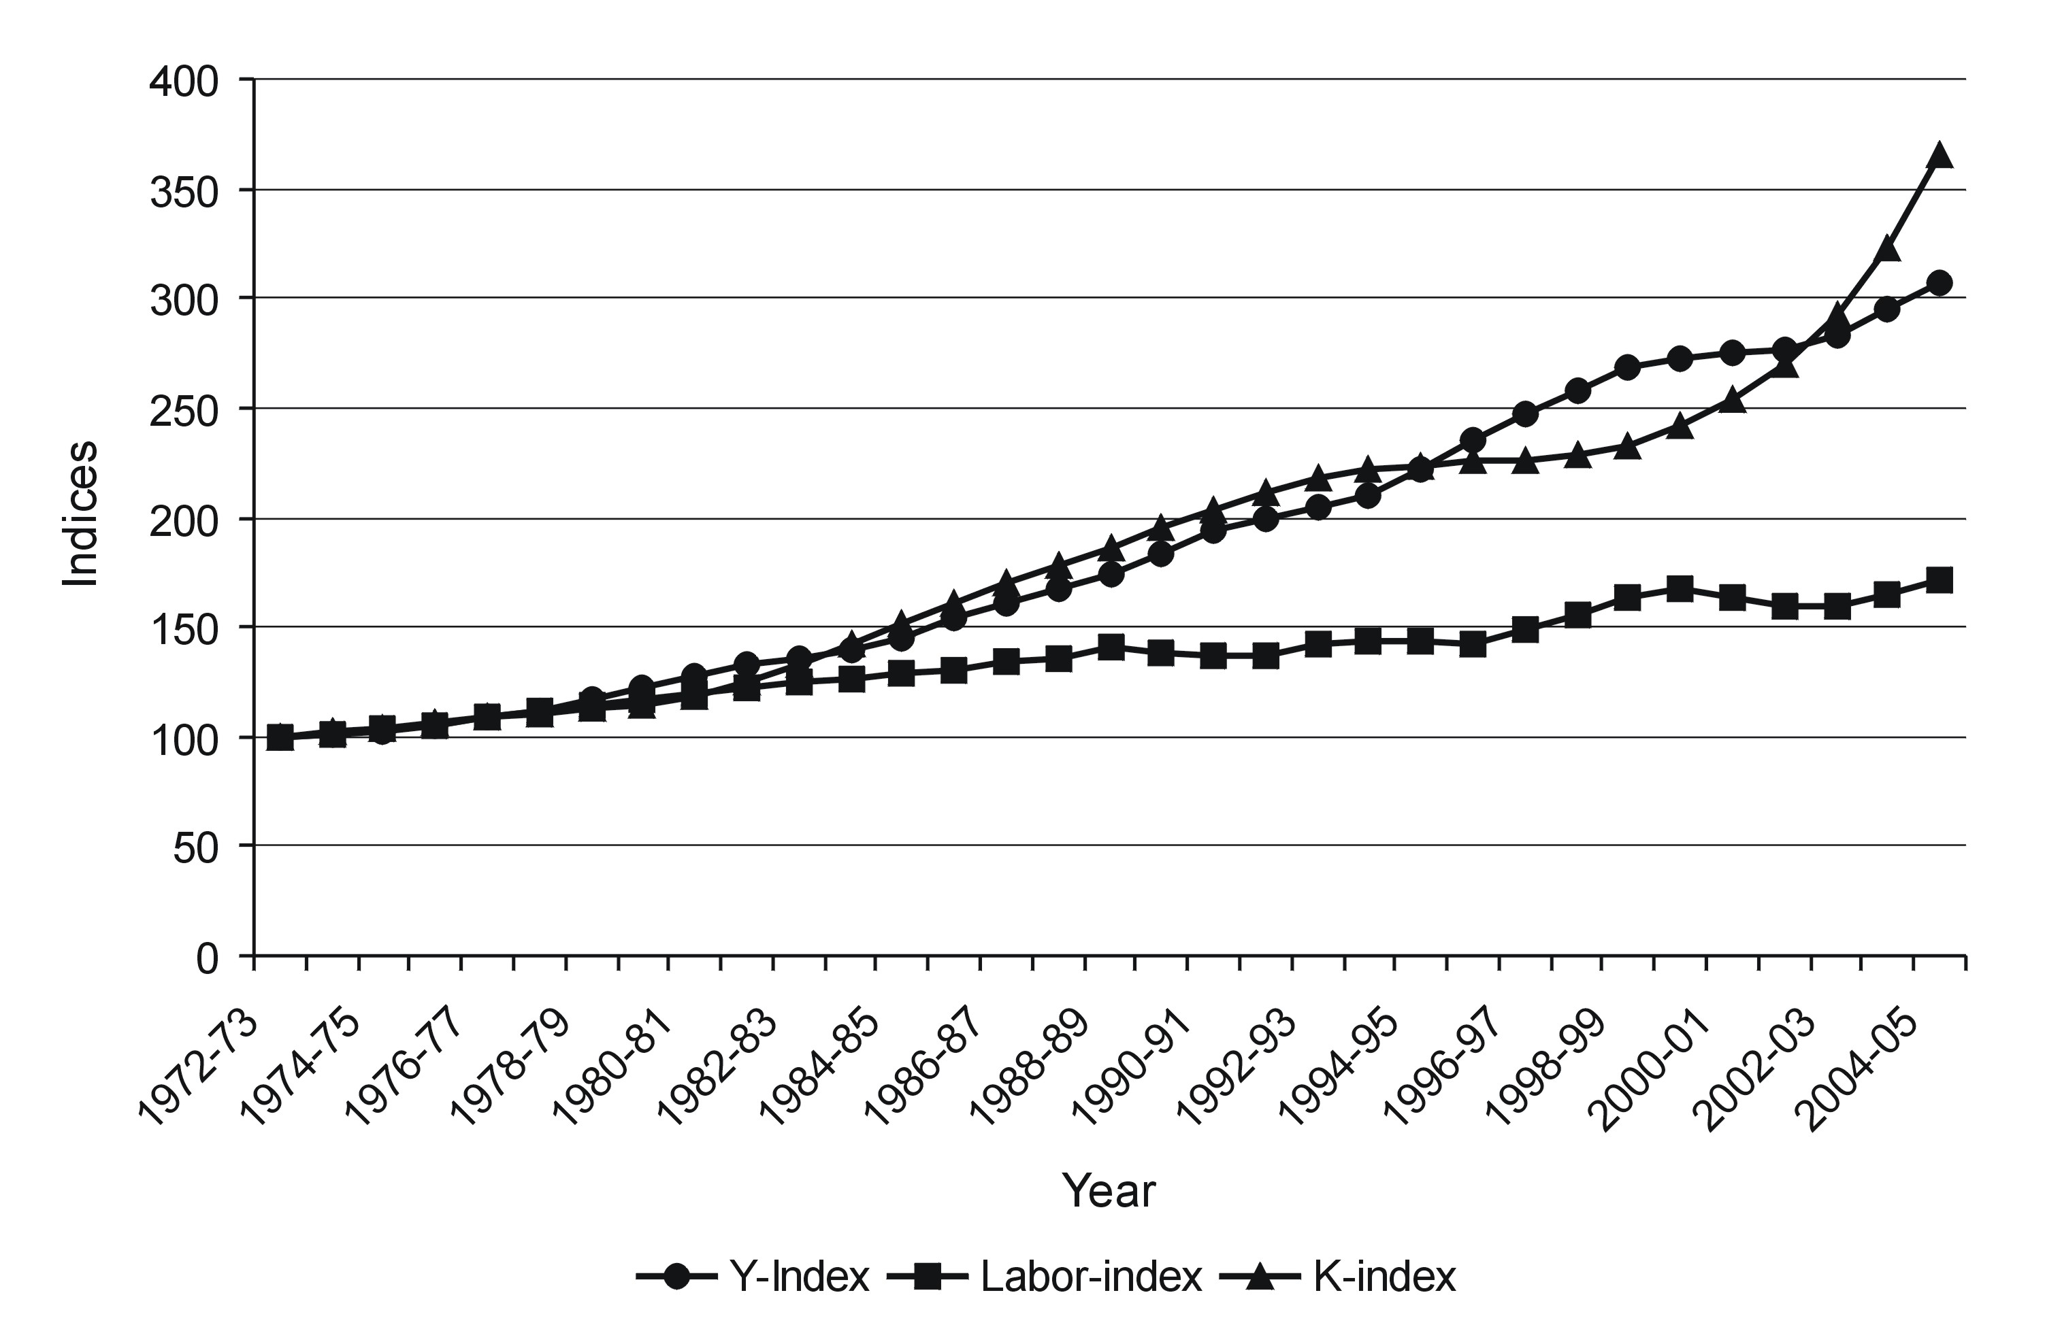
FIGURE 4
Agriculture Capital-Labour and Land-Labour Ratio Indices
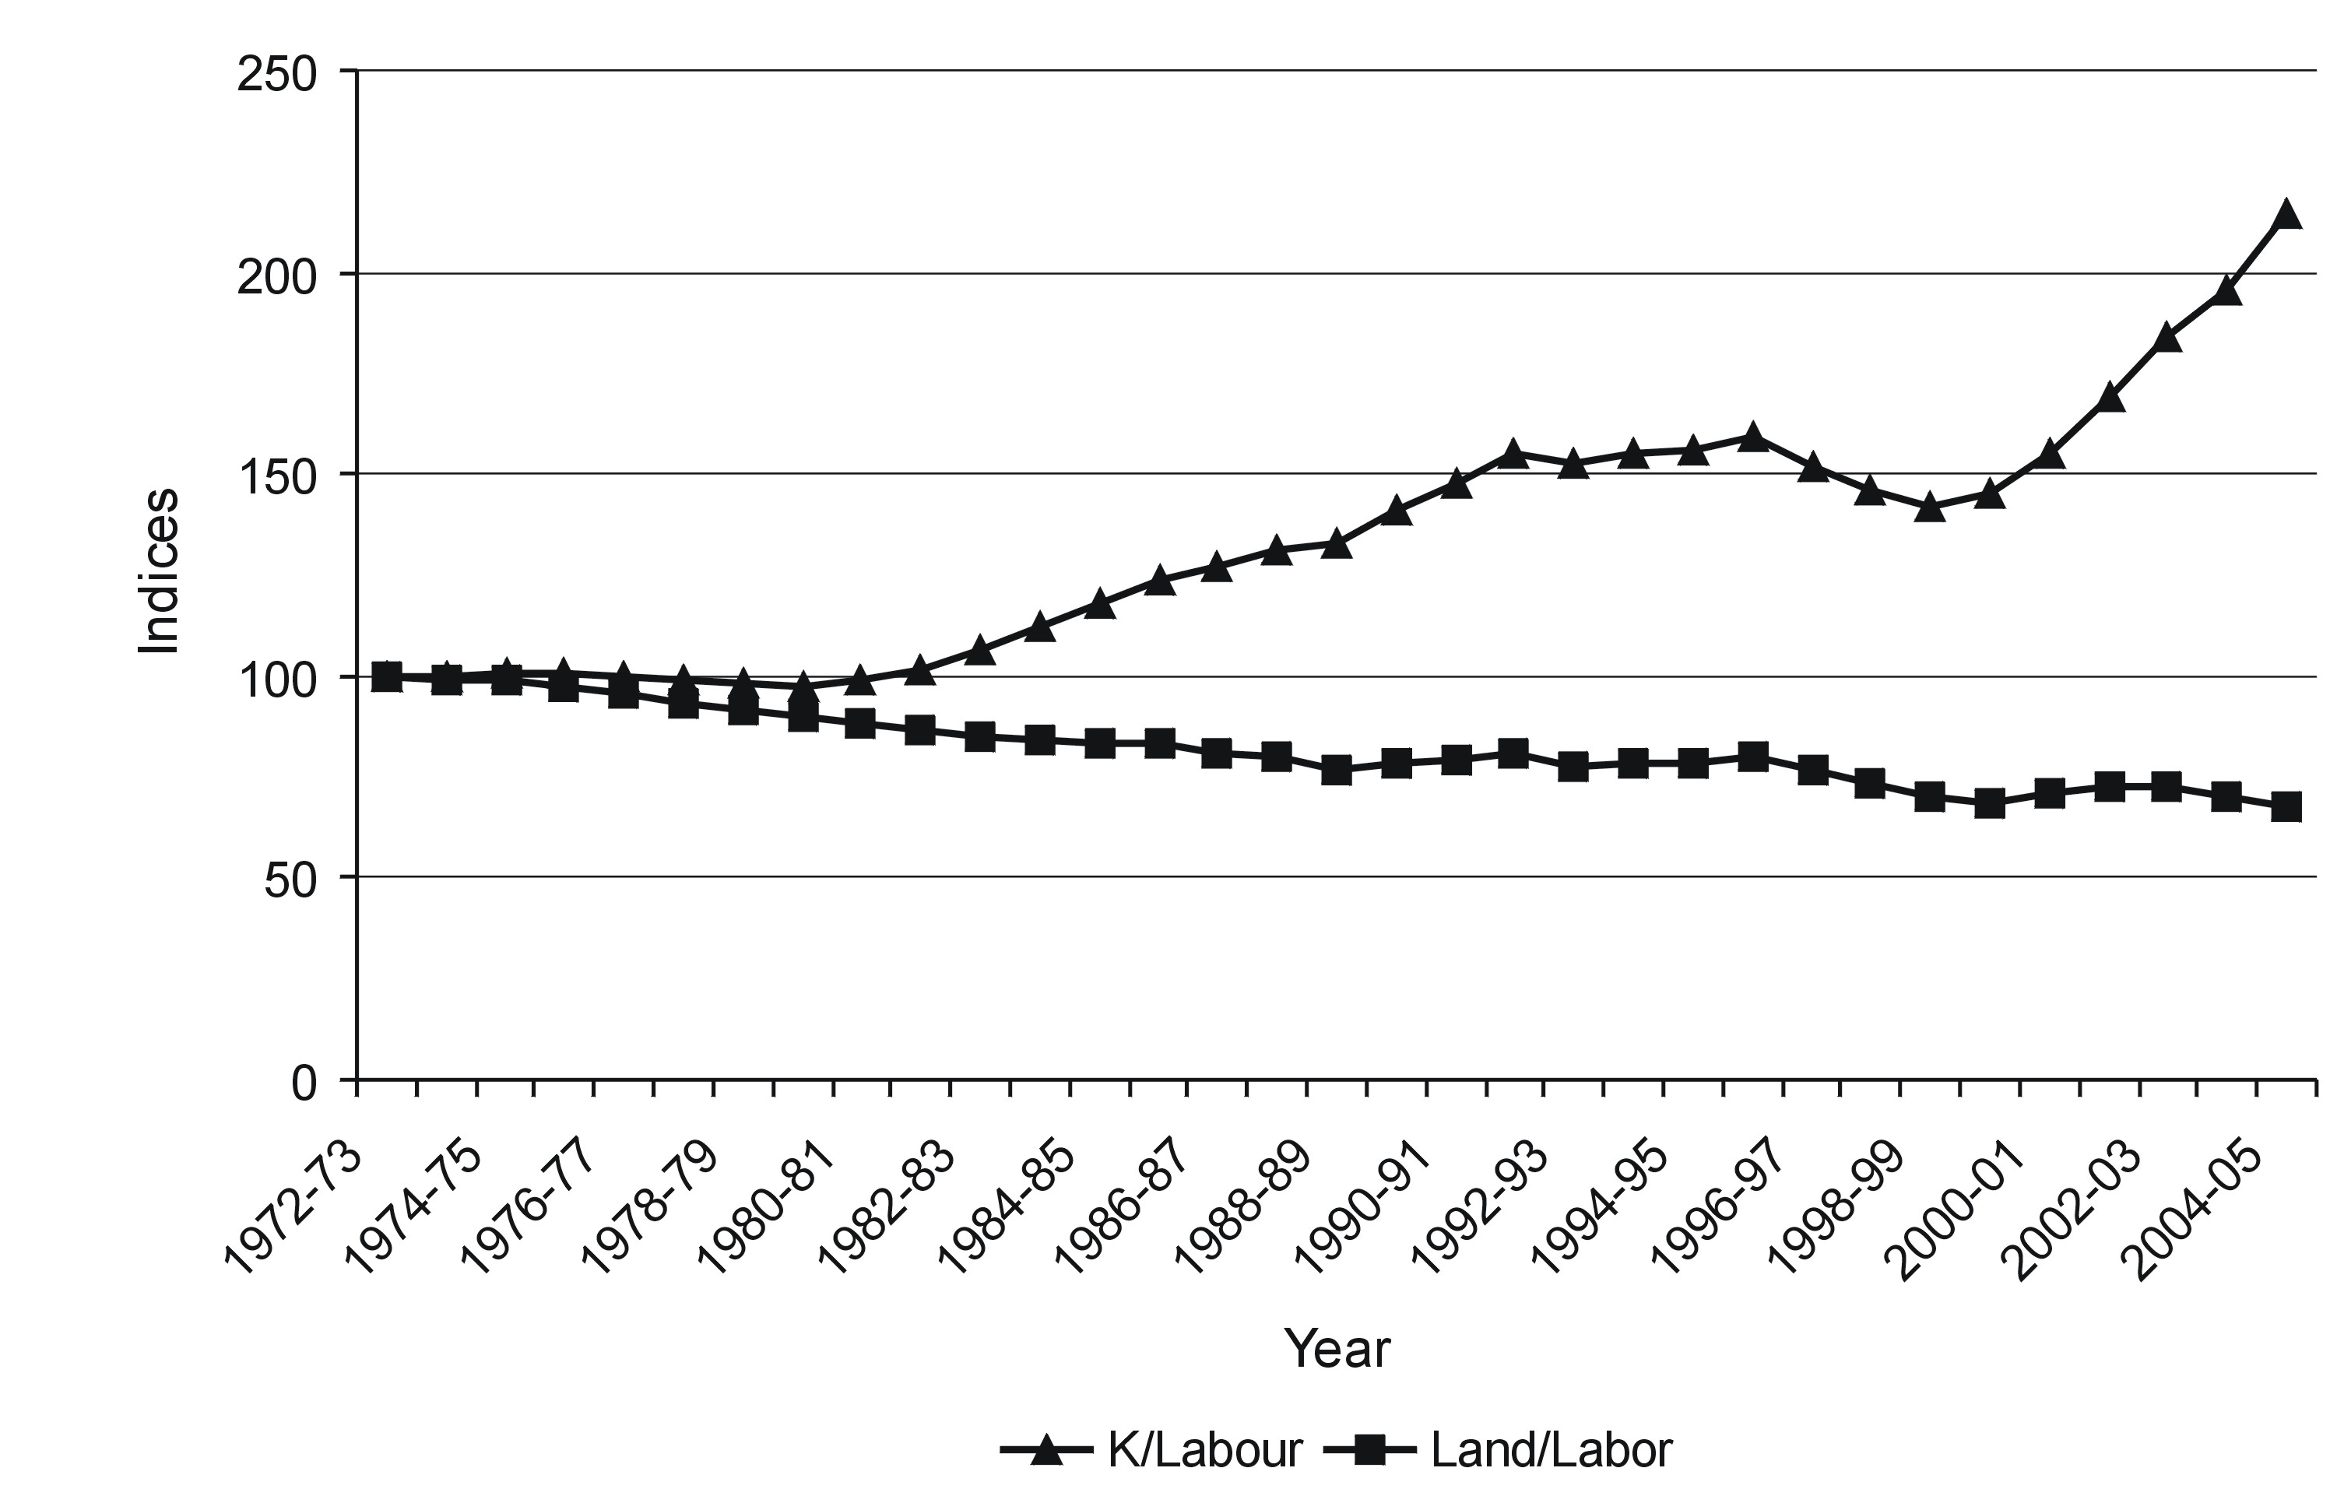
labour absorptive capacity has been squeezing overtime. The provision of employment opportunities to the displaced labour from the agriculture sector due to modernization and new entrants with general or no education in the labour market will be one of the most crucial challenges for the policy makers and planners in Pakistan.12

V. SUMMARY AND CONCLUSIONS
Empirical findings show that major contributors in the agriculture value-added growth are conventional factors of production. Human capital is contributing insignificantly. Labour productivity remained not only low but it also declined over time. Land-labour ratio also declined during the sample period. These results show that agriculture sector which has been the mainstay for the economy of Pakistan is not working according to its potentials. Policy makers have failed to provide any stable infrastructure and required skilled human capital which could enable this sector to work on commercial and competitive basis. Based on the above analysis following suggestions are made:
● Agriculture, producing still on a traditional basis, needs to be com-mercialized and made more competitive by facilitating modernized packing, storing and food processing, in particular, for perishable items like fruits, vegetables, live stock and meat products.
● Development of agro-based and small-scale industries will not only provide opportunities to commercialize agriculture but also enhance employment in rural areas.
● Millions of acres still remain uncultivated due to lack of irrigation and non-availability of other inputs calling on policy makers to pro-actively address these issues by giving them priority.
● Addressing the informal sector as a strategy to enhance living and employment conditions to a wider segment of the population by way of providing micro-loans, basic managerial guidance and training.
● Though highly sophisticated technology is essential for the economy, but along with this, medium and small enterprises with more labour-intensive technology must also be given due attention.
● Strengthening of agriculture research and development activities by emphasizing on vocational and technical training and agro-based professional education so that agriculture sector can be made more commercial and competitive.

REFERENCES
Ali, K. and Abdul Hamid (1996), Technical change, technical efficiency and their impact on input demand in the agricultural and manufacturing sectors of Pakistan. The Pakistan Development Review, Volume 35(3), pp. 215-228.
Bravo-Ureta, Boris E. and Antonio E. Pinheiro (1997), Technical, economic, and allocative efficiency in peasant farming: Evidence from the Dominican Republic. The Developing Economies, Volume XXXV(1), pp. 48-67.
Burney, N. A. (1986), Sources of Pakistan’s economic growth. The Pakistan Development Review, Volume 25(4), pp. 573-589.
Collins, S. M. and B. P. Bosworth (1996), Economic growth in East Asia: Accumulation versus assimilation. Brooking’s Papers on Economic Activity, Volume 2, pp. 135-203.
Fan, Shenggen (1999), Technological change, technical and allocative efficiency in Chinese agriculture: The case of rice production in Jiangsu. EPTD Discussion Paper No. 39. Washington, D.C.
Government of Pakistan, Agriculture Census (Various issues). Islamabad: Agriculture Census Organization, Statistics Division, Federal Bureau of Statistics.
Government of Pakistan (1999), 50 Years of Pakistan in Statistics, Volume I-IV. Islamabad: Federal Bureau of Statistics.
Government of Pakistan, Pakistan Economic Survey (Various issues). Islamabad: Finance Division.
Government of Pakistan, Labour Force Survey (Various issues). Islamabad: Statistics Division, Federal Bureau of Statistics.
Government of Pakistan, Pakistan Education Statistics (Various issues). Islamabad: Academy of Education Planning and Management, Ministry of Education.
Government of Pakistan, Pakistan Statistical Yearbook (Various issues). Islamabad: Statistics Division, Federal Bureau of Statistics.
Hadjimichael, M. T., D. Ghura, M. Muhleisen, R. Nord and E. M. Ucer (1995), Sub-Saharan Africa Growth, Savings and Investment, 1986-93. Washington D.C., International Monetary Fund.
Harberger, A. (1978), Perspectives on capital and technology in less developed countries. In: Artis, M. and A. Nobay (eds.), Contemporary Economic Analysis. London: Croom Helm.
Hicks, N. L. (1979), Growth vs basic needs: Is there a trade-off? World Development, Volume 7, pp. 985-994.
Kemal, A. R. and Islam Ahmed (1992), Report of the Sub-Committee on Sources of Growth in Pakistan. Islamabad: Pakistan Institute of Development Economics.
Kemal, A. R. (1993), Sources of Growth in Pakistan. Report on Economic and Social Well-being for the Eighth Five Year Plan.
Kemal, A. R., Muslehuddin and Usman Qadir (2002), Global Research Project: Pakistan Country Report. Dhaka: Global Research Project Workshop.
Khan, Safdar Ullah (2006), Macro determinants of total factor productivity in Pakistan. State Bank of Pakistan Working Papers, February, No. 10.
Mathijs, E. and L. Vranken (2000), Farm Restructuring and Efficiency in Transition: Evidence from Bulgaria and Hungary. Selected paper for American Agricultural Economics Association Annual Meeting, Tampa, Florida, 30 July to 2 August.
Mundlak, Yair (2005), Economic growth: Lessons from two centuries of American agriculture. Journal of Economic Literature, Volume XLIII (December), pp. 989-1024.
Nehru, V. and A. Dhareshwar (1993), A new database on physical capital stock: Source, methodology and result. Revista De Analisis Economico, Volume 8, pp. 37-59.
Rattso, J. and H. Stokke (2003), Learning by doing and domestic and foreign technology spillovers in Thailand: Some empirical evidence. Nordic Journal of Political Economy, Volume 29(1), pp. 47-66.
Robinson, Sherman (1971), Sources of growth in less developed countries: A cross-section study. Quarterly Journal of Economics, Volume 85(3), pp. 391-408.
Swinnena, Johan and Liesbet Vrankena (2006), Causes of Efficiency Change in Transition: Theory and Cross-Country Survey Evidence from Agriculture. Department of Economics & LICOS-Center for Transition Economics Katholieke Universiteit Leuven, April, Discussion Paper 172/ Version: 5.
World Bank, World Development Report (Various issues).
UNDP (1990), Human Development Report 1990. New York: Oxford University Press.
UNDP (2006), Human Development Report 2006. New York: Oxford University Press.
UNDP (2006), Trade on human terms transforming trade for human development in Asia and the Pacific. Asia-Pacific Human Development Report 2006. UNDP Regional Centre, Colombo, Sri Lanka.
Wizarat, Shahida (1981), Technological change in Pakistan’s agriculture: 1953-54 to 1978-79. The Pakistan Development Review, Volume 20(1), pp. 427-445.
Yanrui, Wu (1995), Productivity growth, technological progress and technical efficiency change in China: A three sector analysis. Journal of Comparative Economics, Volume 21(2), pp. 207-229.
Yanrui, Wu (2000), Is China’s economic growth sustainable? A productivity analysis. China Economic Review, Volume 111, pp. 278-296.

* The authors are, respectively, Ph.D. Economics fellow at the Vienna University of Economics and Business Administration (WU-Wien), Austria, and Assistant Professor of Economics at the University of the Punjab, Lahore-54590 (Pakistan). (E-mail: hafizkhalil62@eco.pu.edu.pk)
1 For details please see Government of Pakistan, Pakistan Economic Survey 2006/07.
2 Various definitions like trade to GDP ratio, sum of agriculture exports and imports, share of agriculture exports and imports to total trade etc, are used to measure the impact of openness of the economy on the agriculture growth.
3 The traditional Cobb-Douglas production function assumes as factors of production labour and capital, and constant returns to scale; i.e. the sum of elasticities of output with respect to labour and capital is equal to one.
4 If capital stock is measured at the end of the year, current year investment is used and if capital stock is calculated at the beginning of the year, previous year investment or gross fixed capital formation is used. We have calculated the capital stock at the beginning of the year.
5 Several other studies use 4 percent depreciation rate [e.g., Nehru and Dhareshwar (1993), Collins and Bosworth (1996) and Khan (2006), etc.].
6 Four years lag for enrollment in the agriculture professional colleges, universities and other institutes is used to measure human resource development impacts in the agriculture sector.
7 Government of Pakistan, Pakistan Economic Survey 2005/06.
8 Agriculture Labour Productivity is calculated by dividing agriculture value-added at constant prices of 1980/81 by the labour employed in the sector.
9 The value of Agriculture value-added and labour productivity is given at constant prices of 1980/81.
1 0The values of indices are given in three years moving average.
1 1K/L values are at constant prices of 1980/81.
1 2As agriculture has been the main absorber of labour force with no or general education. Mechanization and modernization of agriculture over time will squeeze the opportunities for such type of labour force and there will be more demand for technically and professionally trained labour force.

